Final analysis and recommendations related to the current SEI’s Business Process Management System (BPMS)

Project MK-10-IB-EN-01
Activity no: 3.1
(missions 3.1.1.a, 3.1.1.b, 3.1.2, 3.1.3.b, 3.1.4)

Prepared by:
José Gil de Bernabé
José Francisco Alonso Picón
Jasminka Drazenovic
Adam Nadolski
César Seoánez

July 2016

List of Acronyms
  BPMS | Business Process Management System
  EC  E-PRTR | European Commission  European Pollutant Release and Transfer Register
  IC | Inspection Council
  IED  IRAM | Industrial Emissions Directive 2010/75/EU  Integrated Risk Assessment Method
  IPPC | Integrated Pollution Prevention and Control
  LoE | Law on Environment
  LoIS | Law on Inspection Supervision
  LSGU | Local Self-Government Unit
  MoEPP | Ministry for Environment and Physical Planning
  MLSGU | Ministry of Local Self-Government Units
  MNEIS
  NGOs | Non-Governmental Organisations
  OS
  RMCEI | Recommendation 2001/331/EC of the European Parliament and the Council providing for minimum criteria for environmental inspections in the Member States
  SEI | State Environmental Inspectorate
  TA | Technical Assistance
  TFS | Transfrontier Shipment of Waste
  ZELS | Association of the Units of Local Self-Government of the Republic of Macedonia
  Business Process Management System
  European Commission
  European Pollutant Release and Transfer Register
  Inspection Council
  Industrial Emissions Directive 2010/75/EU
  Integrated Risk Assessment Method
  Integrated Pollution Prevention and Control
  Law on Environment
  Law on Inspection Supervision
  Local Self-Government Unit
  Ministry for Environment and Physical Planning
  Ministry of Local Self-Government Units
  Macedonian National Environmental Information System
  Non-Governmental Organisations
  Operative System
  Recommendation 2001/331/EC of the European Parliament and the Council providing for minimum criteria for environmental inspections in the Member States
  State Environmental Inspectorate
  Technical Assistance
  Transfrontier Shipment of Waste
  Association of the Units of Local Self-Government of the Republic of Macedonia

Contents
1. Executive summary 6
2. Assessment of SEI’s BPMS 6
2.1. Preliminary important comment: linkage with IRAM 6
2.2. Description of SEI’s BPMS 6
2.2.1. Inspections management module 7
2.2.2. E-archive module 7
2.2.3. Supporting documents 8
2.2.4. Maintenance of the BPMS 8
2.2.5. Hardware of the BPMS 8
3. Next steps for implementation of SEI’s BPMS inspection module 8
4. Gaps and potential areas of improvement 10
4.1. Connectivity between the BPMS and other information systems: E-PRTR, IRAM and GIS 10
4.1.1. Connectivity to the E-PRTR system 10
4.1.2. Connectivity to IRAM software 11
4.1.3. Connectivity to GIS 12
4.2. Other gaps affecting all kinds of inspections 12
4.2.1. GAP 1: The system planned to capture data from other information existing or future systems of this institution and MoEPP departments (water, permits, PRTR, ...) is unknown 12
4.2.2. GAP 2: The module does not include management indicators and executive summaries of the inspection processes 13
4.2.3. GAP 3: The BPMS is not used to facilitate communication with other authorities to request inspections 14
4.2.4. GAP 4: The Sharepoint tool to view Gantt diagrams of the processes is not in place 15
4.2.5. GAP 5: Part of the information about inspections performed should be available for consultation by all personnel related to environmental inspection. 15
4.2.6. GAP 6: The module does not include features to ensure the compliance with Directive 2003/4/EC on public access to environmental information 15
4.2.7. GAP 7: The inspection module has only one mode of operation, and has no mode for testing the system or trying new updates. 16
4.2.8. GAP 8: The current user manual does not have the level of detail necessary for users with low computer knowledge, and there is no manual for the future BPMS administrator. 16
4.2.9. GAP 9: introduced documents are in non-editable format which makes it impossible to obtain the information about the content. 17
4.2.10. GAP 10: Insufficient setup to generate a variety of reports about the inspection activities 17
4.2.11. GAP 11: The software is not designed to support the annual planning of inspections and to remind inspectors about pending tasks 18
4.3. Gaps affecting implementation of inspection-related prescriptions in the IED 18
4.4. Gaps related to the maintenance of the BPMS 20
4.5. Upgrading BPMS: version, license, securing storage and disaster recovery 20
4.5.1. Assessment of hardware and software gaps and required updates 20
4.5.2. How to upgrade: partially in the cloud, or everything in premises 25
4.5.3. Summary and main conclusions 28
4.6. National best practice to follow: Food and Veterinary Agency 28
5. Proposals on the way to upgrade the BPMS in the middle and long term 29
5.1. First supply contract (implementation expected to start earliest 12/2018) 30
5.1.1. To take into account: proper linkage with external relevant databases 30
5.1.2. Additional hardware 30
5.1.3. Upgrading of software 32
5.2. Second supply contract (implementation expected to start earliest 12/2019) 33
5.2.1. To take into account: proper linkage with external relevant databases 33
5.2.2. Additional hardware 33
5.2.3. Upgrading of software 34
Annex 1: EU best practice: general information management system & IED inspection software in Galicia (Spain) 35
Annex 2: Screenshots of BPMS, showing some of its functionalities and suggesting (in red) some improvements 48
Annex 3: Example of Croatian internal guidance of the Ministry of Culture for the definition of specifications in IT maintenance contracts 54

Executive summary

This document collects the results and conclusions of the assessment performed to the Business Process Management System (BPMS) currently being tested in order to be used by SEI and local authorised environmental inspectors.

In section 2 such assessment is performed, describing the key features of the BPMS. Section 3 proposes a calendar for its implementation, while section 4 focuses on detected gaps and possible improvements to deal with them. Discussion is made as well in that section of possible improvements required in order to cope with the requirements of article 23 of the Industrial Emissions Directive (IED) for the case of installations falling under the scope of IED.

Section 5 discusses, as a consequence of the gaps detected in section 4, the need for a follow-up project to further upgrade the BPMS.

Based on the assessment and proposals in sections 2 – 5, section 6 proposes potential topics for the remaining missions within activity 3.1 of this Twinning project, to contribute to the implementation and further development of the BPMS.
As was found during the mission in February 2016 the procedure to tender the secure internet connection for SEI is still unfinished. The insufficiency of the hardware for a sustainable usage in the middle term has to be mentioned (in particular regarding storage, back-up system and disaster recovery, which should be indeed a concern in a seismic area like Skopje). It is essential for for the sustainability of the system in the future to upgrade the hardware gaps, licences for server and also to ensure security and integrity of data stored in the BPMS.

Assessment of SEI’s BPMS

Preliminary important comment: linkage with IRAM
In line with EU best practices in the field of environmental inspections, work has been carried out to use the IMPEL risk assessment tool IRAM as the key tool to prioritise environmental inspections and to elaborate plans.
Ideally proper linking between the current BPMS and IRAM should be ensured, to avoid that environmental inspectors have to input the same data several times, but only 1 time.

Description of SEI’s BPMS
The application is based on SharePoint tool, designed for multitask process management and many users, among whom the information is shared.
The processes that are managed in this system are not only inspections, but also monitoring tasks, elaboration of inspection plans, etc.
There are two modules, one for the management of inspections and another for the e-archive of SEI.

Inspections management module
The system works this way for the case of management of inspections:
The inspector who according to the inspection plan will carry out an inspection, each time he will want to implement one will open a new process and the system assigns to it an identification number. Since then, only the inspector may enter and modify the information needed for the inspection or generated by the inspection and only s/he and SEI Director can access it.
During the course of the inspection, the inspector enters the time needed to carry out the inspection, selects the plan to which it belongs (in the case analyzed, it was the supervision plan), inspection type (“ordinary” (=planned), “extraordinary” (=unplanned) or “monitoring” (=follow-up of a previous inspection process)). The inspector can also upload files and comments that are needed to perform the inspection and in the end of the process uploads documents such as the minutes, report, sampling results. After the inspection and related reporting is considered as concluded, the process is closed and the system sends an email to SEI Director, who can see all what has been done.
The system has on the left side a menu, in which inspectors and supervisor may click and view active inspections, closed inspections, general information about the installations subject to inspection (location, contact, permits, etc.).
Inspections to a given installation are usually assigned always to the same inspector. The software allows the inspector to see the information on inspections carried out by him/her to a given company, using a search engine, where keywords are written. An inspector cannot see information related to inspections carried out by other inspectors, unless given permission by the Director of SEI. Should for any reason (illness, holidays...) other inspectors have to perform a visit to a company which is usually not allocated to them, SEI Director may authorize them to look in the system to the inspections carried out to the corresponding company by the inspector who is absent.
According to the information received about the BPMS it is possible to generate reports related to company (which can have one or several installations), the region or city. There is no possibility to provide such lists or reports related to an individual installation.

E-archive module
The system also features a document management module (“e-archive”) where it is possible, for each installation subject to inspection, to find the documents/info sent by the installation and those generated by the inspections to that installation.
Once an inspector uploads a file with the corresponding code number, it appears in the e-archive module.
The archivist and SEI Director can have access to all files related to a given company. An inspector needs to request access to files of inspections not performed by him/her.
The way that the e-archive module is set-up, and the corresponding limited access to it, is derived from national legislation on storage of information for public institutions.

Supporting documents
A brief manual has been developed for users, complemented by a couple of explained study cases of inspection procedures.
So far no guidance for the future administrator of the BPMS has been delivered.
A more detailed manual, addressing both users and the administrator of the BPMS, will be delivered by the company who developed the BPMS. For further information, see section 4.2.9.

Maintenance of the BPMS
Currently there is no IT staff in SEI. For the first year of implementation of the BPMS (its warranty period) the consultancy company that developed the BPMS will provide support to SEI.

Hardware of the BPMS
Currently the hardware for the BPMS includes the features shown in the first column of the table in section 4.5. In that section an assessment is made of them, and of suggested improvements to avoid bottlenecks. In any case it must be mentioned that the current hardware will not be capable of running the expected upgrades to be implemented in the future (see section 4), including the addition of more users or functionalities.

Next steps for implementation of SEI’s BPMS inspection module
A tender procedure to provide secure internet connection to all SEI branch offices finalized in April, with internet connection provided up to the end of May. In addition, the E-Archive module is expected to become operative in May 2016. A second stage to provide secure internet connection with local authorities environmental inspectors is envisaged, but its implementation calendar is uncertain.
The following steps to implement SEI’s BPMS inspection module are proposed, focusing on a first stage on SEI inspectors, and on a second stage on local authorized environmental inspectors:
- In June 2016 a group of SEI inspectors should be trained on the use of the BPMS, and be requested to insert cases and test the BPMS. It is suggested to devote 1 week in June 2016 to such testing. The training should be based on the user’s manual, to discover points to improve both in the manual and the inspection module.
- After making the corresponding improvements in the manual and the inspection module (up to the end of June 2016), a training program for the rest of SEI inspectors and some local authorized inspectors with whom collaboration is better is proposed for the first half of July 2016: at least 1 day per group. It has to be kept in mind that training will require a number of available computers and access to the application server.
- Coming back to the testing, it is proposed to test the module by inspectors who participated in the training until the last week of June 2016, creating as many fictitious cases as possible, noting the problems encountered and communicating them to the module developer for their correction.
- Meeting of the team that tested the module with the module developer, to validate the software or discuss the last changes required. It is proposed to take place in July 2016. If changes are proposed, they should be delivered up to the end of July 2016.
- In parallel, in the months of May-June 2016, the module developer should train the staff at SEI that will be in charge of the maintenance and further development of the module.
It is essential that the developer of the module gives to the SEI the source code and information needed to make changes to the module in the future.
- As a provisional target the module could start to be used by the SEI inspectors no later than end of May 2016.
- Implement gradually the inspection module for the case of local authorized environmental inspectors. As criteria to establish an order of municipalities in which the module will be implemented it may be emphasized:
  - Attitude of the corresponding local inspectors to the use of the new module.
  - Availability of computer, access to the BPMS and internet connection.
- In addition, steps have to be taken in May-July, to:
  - Define with good approximation the budget required to implement the upgrades of hardware and software in the short, middle and long term.
  - Define the ways that are available to get the required funding and means to implement such upgrades.
  - Complete the libraries in the BPMS with useful information for inspectors.
A meeting with representatives of the Food & Veterinary Agency, to learn about their experience in the establishment of software to support inspection activities, is as well recommended for May-June.

Gaps and potential areas of improvement

Connectivity between the BPMS and other information systems: E-PRTR, IRAM and GIS

Connectivity to the E-PRTR system
The EU E-PRTR register includes all information related to activities carried out in IPPC (and other) installations, the amounts of emissions and waste generated and the supporting documentation for this information. This information should be used in the inspections to ensure the quality of the data provided by facilities in their statements.


Hazardous waste (transboundary)
Non-hazardous waste (within the country or transboundary)
Off-site Waste-Water Treatment Plant
Identification of
the facility
Facility
¹⁾ Waste which is subject to disposal operations “land treatment” or ”deep injection”, shall be reported as release to land by the operator of the facility originating the waste
Releases
water
air
Hazardous. waste (within the country)
Quantity of pollutants
Off-site transfers
Quantity of waste
land
¹⁾

BPMS connectivity with the E-PRTR: Although the BPMS might be connected to the E-PRTR thanks to the fact that there is a field identifying each facility, in practice this connection would be very complicated and not very operational in view of the way that the information obtained during the inspection process is stored. Therefore, in practice the inspectors may access the Macedonian E-PRTR by generating users and user profiles via internet browser or via a link included in the BPMS.

Connectivity to IRAM software
In line with EU best practices in the field of environmental inspections, work has been carried out to use the IMPEL risk assessment tool IRAM as the key tool to prioritise environmental inspections and to elaborate plans.
As a first approximation to this system SEI will use a few parameters to characterize each installation, providing numerical answers to a short list of questions and depending on the answer, the risk index is calculated. See figure below with a snapshot of such a list of questions/topics and numerical scoring:
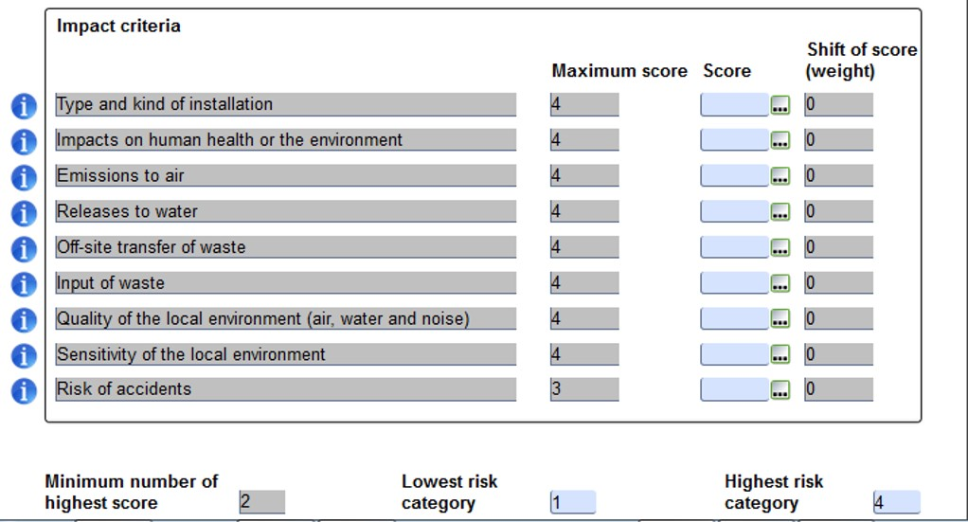

This risk index is calculated prior to the preparation of the inspection program and the results of the inspection may modify it, so ideally the BPMS should connect these outputs with the IRAM. However, given the features of the current BPMS tool, this connection would be complicated and would not be able to provide much information useful for IRAM.
Recommendations:
- Given the effort that would be needed for this connection and the limited results that seems that would be obtained, the connection between these two systems is not considered as recommendable.
- As shown in more detail in the slide 1 of Annex 2, it will be useful to include as a field in the BPMS the IRAM score of an installation in order to help inspectors to build a better picture of the installation and define the frequency of planned inspections.
- Besides, to define in a unique way a given installation, it is proposed to use the official ID number of the corresponding company for legal purposes, complemented by the code that the installation has been given in IRAM. In this way a unique ID is ensured, and at the same time is a way to link both softwares.

Connectivity to GIS
Next updates in the BPMS must also address the use of available GIS data (coordinates and data) from the Macedonian cadastre authority, see such data in the following web links:
http://www.katastar.gov.mk/en/
http://ossp.katastar.gov.mk/OSSP/faces/public/customMaps/TK25000TematskiSloeviListovi.xhtml
http://makpos.katastar.gov.mk/SpiderWeb/frmIndex.aspx
It must be mentioned that mapping and GIS data are included in the features of the Macedonian National Enviromental Information System (still to be developed).

Other gaps affecting all kinds of inspections

GAP 1: The system planned to capture data from other information existing or future systems of this institution and MoEPP departments (water, permits, PRTR, ...) is unknown
It is considered essential to establish as connecting element for the different environmental information systems that will be developed by the SEI and the MoEPP (environmental permits, PRTR, waste, emission sources...), the Unique Identification Number of Entity (identifying uniquely companies in the Republic of Macedonia) plus an additional identification number to distinguish each installation within the company (which can be the IRAM ID, as stated in section 4.1.2) and its physical location (address or spatial data from the cadaster), and a unique number identifier of the whole company or entity. These fields should appear in all databases, so that they can export data between different databases based on this common element. It must be emphasized once more that data must be input only once.
See as well preliminary note (section 2.1) and recommendations therein regarding connection with IRAM software.
The example of the region of Galicia, Spain
In the case of Galicia, every installation that can be subject to environmental inspection is assigned a reference number that serves as unique reference for all environmental information systems. Of course every time a new system is going to be developed, analysis should be made of the information to be handled, identify the shared data and the people responsible for its creation and maintenance.
In Galicia, at the moment, the following systems, connected as described above, are in place:
1. Solid waste management information system
2. Information system concerning disciplinary proceedings opened on the basis of an inspection
3. E-PRTR
4. Information system on emissions of volatile organic compounds, VOC.
5. Information system for facilities that have emission points which must be subject to measurements.

GAP 2: The module does not include management indicators and executive summaries of the inspection processes
As mentioned, the BMPS is designed as a project management system in which each inspection is a project, so that the information loaded into the system is not oriented towards the facilities which are inspected, but is linked to the inspection procedures (see section 2.2.1 and slide 1 in Annex 2). On top of it, this information is uploaded in files to be added throughout the process making it impossible to manage the data included therein.
But management indicators and summaries are very useful for SEI Director and for planning and reporting purposes, in particular the following information:
- List of installations that should be subject to follow-up inspections
- Companies that were visited, purpose of the visits and main results of each inspection. E.g. this report is essential in Galicia. To include this information in the module, one or several new fields should be added, where the following info would be inserted:
  - Reason to carry out the inspection (including defined objectives in case of planned inspections)
  - Main results
  - If a disciplinary procedure was performed to the company and the result thereof
  - If there is need for follow-up
  - Fields related to annual, quarterly and monthly reports
- Performance statistics as a function of different variables (municipalities, inspectors, inspection types...), visible not only for managers but for all users of the system, to foster the improvement of the performance of those who make less.
Templates integrated in the BPMS enabling the inputting of data instead of simply uploading files (see section 4.2.9) can increase the utility of the BPMS substantially for managers, by endowing the system with the capability to generate in an automated way different kinds of reports at will.
Although up to now it has not been possible to check the reports that can be made available for each facility due to the lack of uploaded data in the system, it is clear that it is feasible to obtain at least the list of inspections carried out for a given facility.
Suggestions for immediate improvement: If possible, it is proposed to add, within the information requested throughout the inspection process:
- A field in which the inspector indicates whether non-compliances were found, and if so, if they were serious or minor.
- A field for the inspector to include proposed follow-up actions as a result of the inspection (e.g. education, time to solve non compliance, next inspection…). This information is suggested to be included in the final report of the inspection to the facility.
As an example the report of the visits to each facility that the BPMS could generate automatically may include the following fields:
Installation | Site-visit starting date | Inspector in charge | Number of inspection days | Results:  - Serious non compliances  - Minor non compliances  - No non compliances | Follow-up actions
XXX | Xx / xx / xxxx | xxxxxxxxxxx | 4 | Serious non compliances | Operator shall provide proper waste storage for hazardous waste until dd/mm/yyyy
YYY | Xx / xx / xxxx | xxxxxxxxxxx | 2 | No non compliances | ---

GAP 3: The BPMS is not used to facilitate communication with other authorities to request inspections
Specially for the case of the staff in charge of environmental permitting, it would be recommendable for them to have a way to make such requests, where they would be required to specify the information that should be checked and the purpose of the inspection. This would be an input to the SEI manager in charge of planning and distributing the inspections among the inspectors, and it would facilitate the communication between permit writers and inspectors.
To avoid random requests, a Captcha filter should be included. It is recommended to enable this kind of access to permit writers.

GAP 4: The Sharepoint tool to view Gantt diagrams of the processes is not in place
To control inspections completed, ongoing and planned, Sharepoint has a Gantt diagrams tool that is not available right now. It should be easy to enable this option, depending on the license. It is suggested that all licenses needed should be provided by central government agreement, and if required to upgrade the software versions, to ensure the availability of the required features.

GAP 5: Part of the information about inspections performed should be available for consultation by all personnel related to environmental inspection.
The information per inspector about (i) number of performed inspections, (ii) number of ongoing and status of inspections, plus (iii) main follow-up conclusions of them, should be available to all staff of the inspectorate. The reason for this change is to promote the improvement of performance of low-performing inspectors and the transparency within the organisation.
In addition, it would be good to have at least a set of examples of well-performed inspections, including well-performed procedures and properly filled templates (of minutes, decisions, etc), to:
- Facilitate the implementation of a single environmental inspection approach.
- For new inspectors to learn how documentation and findings should be provided, by looking at examples from previous inspections.
At least for the case of inspectors that will perform inspections to a facility that has been inspected by other inspectors at some point, they should be granted full access to all the files related to the inspections of the corresponding facility. If they do not have access to information from previous visits, it leads to lack of coordination, damages the image of environmental inspection and at the same time it makes the work of inspectors and of industries more difficult.
It is suggested as well that it will be very practical that, for the case of inspections where several inspectors have been present, the minutes from each inspector that has participated should be combined into one document.

GAP 6: The module does not include features to ensure the compliance with Directive 2003/4/EC on public access to environmental information
It is essential to clearly identify what information must and will be made available to the public or any court. One option would be that those files of a given installation classified as “public” within the e-archive module should be stored also in a folder that can be accessed through SEI’s website.
See in addition the recommendations in section 4.2.10 regarding automated generation of reports.

GAP 7: The inspection module has only one mode of operation, and has no mode for testing the system or trying new updates.
Besides the “normal” mode, used for real inspections, the BPMS must have a test mode in which it is possible to make all kinds of trials, to learn, and it will serve as well to try upgrades to the system. According to discussions held with the IT experts of the Supply Contract that developed the BPMS, such functionality will be in place once the testing period is finished (currently there is only “test mode”).
Independently of that, (fake) examples of inspection processes, should be accessible by all users at any time, so in case of doubts examples can be opened and seen. This will only be possible after buying additional hardware, due to the limitations of the current one.

GAP 8: The current user manual does not have the level of detail necessary for users with low computer knowledge, and there is no manual for the future BPMS administrator.
It would be recommendable to develop more in detail the BPMS manual, to be understandable for users with very low level of computer knowledge. At the beginning of the manual there should be a glossary which explains the terms like “process”, “activity” “record”, etc. Also all elements visible on the screen should be explained in a detailed way (e.g. how a screen is organized, what is visible on the top and on the right, how to add new process, choose option, etc.). The manual should also explain how to search needed information, how use the filters and how to create reports. BPMS allows also to prepare new templates of reports. The templates can be done by an administrator of BPMS. The manual should include detailed information on how the templates of the reports can be created.
A specific manual or section within a manual, for the future BPMS administrator, has to be developed, that explains everything needed for maintaining the contents of the system and supervising the correct usage by the users. It is also recommended that the manual should be divided according to different kinds of users, so that each instruction/subsection presented in the manual should mention explicitly to which of the users is targeted.
More information should be provided about what kind of document can or should be uploaded to the BPMS or which uploaded documents are crucial for different purposes.
In addition, due to the complexity of the IT maintenance and upgrading of the system, it is recommended to outsource this kind of IT maintenance and development. It would be recommendable to develop a third manual with guidance for the IT maintenance and development of new modules.
The BPMS should also include some hints with suggestions about the entered data (e.g. help button, short movie, pop-up windows with explanations about how to complete the corresponding fields, etc.). The BPMS should not allow to save uncompleted data (in case of information considered as crucial).
More detailed proposals and suggestions to improve the existing manual: “HOW TO USE THE BUSINESS PROCESS MANAGEMENT MODULE” have been provided in a separate document to SEI beneficiaries and to the staff of the IT company in charge of the BPMS.

GAP 9: introduced documents are in non-editable format which makes it impossible to obtain the information about the content.
In the current BPMS very important information about the inspections, like the contents of the minutes, is uploaded as scanned pdf files or pictures. The next step in this direction should be part of a thorough upgrade of the BPMS, so that the software enables the user to fulfil electronic templates within the software (like minutes on inspection findings, minutes to justify and request mediation procedure, etc.), which will allow to get the relevant information about the inspection (results, instructions delivered to the controlled company, etc.). According to EU experience, such templates are very useful to collect necessary data for planning and to for the delivery in an almost automated way of the reports about the inspection activity. This gap should be solved with a follow-up project, using a new version of SharePoint server software (2016).

GAP 10: Insufficient setup to generate a variety of reports about the inspection activities
Collecting data should be done with a purpose. One of the main goals of an inspection software is to help to prepare the reports about the inspection activity that are required either by law or by managers within SEI and from other public administrations. It should be discussed which kinds of reports are expected to be delivered, and as a function of that proper templates and fields should be included in the upgraded software, to ensure that the required data are included in the system; finally, predefined reports should be prepared which would feed on those data. These reporting features also facilitate the cooperation of inspectors when introducing its use in their daily work, as it is a very clear example of how it will simplify their administrative burden. These predefined reports can be useful, e.g. to prepare annual, quarterly and monthly reports. It is recommended to use, as basis to define two of those kinds of reports, the templates for final inspection report and publicly available inspection report delivered within this Twinning project and available at www.sei.gov.mk .
Proposal for the short term:
Within the current BPMS it is possible to generate reports related to company (which can have one or several installations), region or city. There is no possibility to provide such lists or reports related to an individual installation. But such new feature is possible to be introduced. In annex 2 “Description of BPMS functionality” some specific proposals are shown on how to use the existing fields: “code”, “extension”, “subextension” in BPMS. They are not currently used in BPMS, but they can be used as: “ID of company”, “ID of installation”, “IRAM risk score”. With such defined fields it will be possible to prepare several reports or lists related to an installation or a company (like the history of inspection, lists of decisions, etc). Such lists should be useful for inspectors to gain in a quick way all necessary information before the next inspection and it can be helpful to prepare the reports (like annual or quarterly reports).

GAP 11: The software is not designed to support the annual planning of inspections and to remind inspectors about pending tasks
When preparing the annual inspection programme, for the case of regular inspections SEI management has to take into account 3 factors: (i) the risk score of each installation subject to inspection (obtained through IRAM), (ii) the last time that each installation has been inspected, (iii) any priorities derived from MoEPP’s policies or due to changes in legislation. This can bring some difficulties when choosing the “optimum” set of inspections to be included in the inspection annual programme.
It is recommended to expand the BPMS module for assisting in the preparation of the programme, taking into account the 3 factors mentioned above.
If a BPMS will be equipped with such a module the BPMS should also provide support for the inspectors in the implementation of this programme. It can be done by the system by recalling about pending inspections. Such feature will be very useful to inspectors and SEI management in their daily work.

Gaps affecting implementation of inspection-related prescriptions in the IED
The current inspection module does not include a distinction between installations in Annex 1 of the IED and other kinds of installations.
IED installations are the only ones which have, with respect to environmental inspections, a whole set of precise obligations laid down in EU environmental acquis. Article 23 of the IED configures a specific framework for the inspections of IED installations, with immediate consequences in the way that inspections must be planned, prepared, inspected and reported to public and EC.
The adaptation to this framework is a real challenge which is estimated to take at least a 3 - 4 years to be completed, assuming full commitment by SEI and an institutional and financial framework favorable to the changes that it implies.
It is recommended that in a later mission detailed discussion should take place with the beneficiaries about further development of software that may support SEI in its obligations related to IED art. 23.
The IED inspection framework has the following characteristics affecting different aspects of inspections:
- Inspections are categorized as follows: routine inspections, inspections motivated by serious environmental complaints, serious environmental accidents, incidents and occurrences of non-compliance, or by substantial modifications of the installation.
- The frequency of routine inspections shall be based on a systematic appraisal of the environmental risks of the installation, with a periodicity ranging between 1 and 3 years. The tool widely spread to implement such appraisal is IRAM IMPEL tool.
- These routine inspections imply a very large amount of workload, as for each environmental vector (air, noise, discharge waters, soil, groundwater, waste) it must be checked that the corresponding controls established in the permit have been respected (in terms of parameters and frequencies) and that there has been no surpassing of Emission Limit Values defined for each parameter.
- Deviations from compliance must be categorized for each environmental vector (air, water, etc) according to clear rules, and the degree of compliance with the permit evaluated.
- An environmental report must be prepared after the inspection minutes, within a period of 2 months or in some cases additionally in 4 months. In the latter case the first report will be provisional and the second one will be final.
- The final environmental report must be made available to the public at least through the website of the environmental competent authority.
- Once a year an environmental inspection report about the inspections carried out during the year must be delivered, following the indications stated in Commission Implementing Decision 2012/795/EU on reporting requirements linked to IED implementation.
Galicia’s Regional Competent Authority has developed a specific software for compliance with Article 23 of the IED. This software interacts with the general software of routine environmental inspections and is capable of extracting and sharing data with other databases such as waste, PRTR, VOC (volatile organic compounds) emissions and sources of emissions, or air quality.
The software allows to:
I.- Have all data and information given in the integrated environmental permit and in subsequent modifications of it.
II.- Having all the data of the various controls carried out following monitoring plans defined in the integrated environmental permit for each environmental vector in the period between environmental inspections
III.- Define and assess environmental deviations found for each environmental vector.
IV.- Assess the degree of compliance with the integrated environmental permit.
V.- Re-evaluate after each environmental inspection carried out the environmental risk index (IRAM) and redefine the frequency of the next environmental inspection.
VI.- Obtain the environmental inspection report (interim and / or final).
For more information about it see on Power point presentation included in Annex 1.

Gaps related to the maintenance of the BPMS
Currently there is no IT staff at SEI. Even though for the first year of implementation of the BPMS the consultancy company that developed the BPMS will provide support to SEI, according to the number of SEI inspectors, it is essential to hire at least two IT educated staff, and outsource the maintenance of the system. Their workload will increase during testing and utilization time. From EU experience, they will be essential and necessary to help inspectors and be a liaison with the firm that developed the system and that will have contract for maintenance and potential upgrading. A single IT staff will not be able to deal with the maintenance of the whole system.
Regarding the outsourcing of some of the maintenance services, the cost of a contract for the outsourcing of IT maintenance services depends on the number of servers, communication devices such as switchs, routers, number of users with PC, periferial devices, number of locations and also on the software applications and systems which maintenance is covered by the contract. It is thus recommended that any IT maintenance contract for SEI must be well defined, specifying the number of users, locations, server roles and it must contain remote maintenance for all locations during working hours, and also defining maximum response times to different kinds of failures of the IT system.
An example of Croatian internal guidance of the Ministry of Culture for the definition of specifications in IT maintenance contracts is shown in Annex 3.

Upgrading BPMS: version, license, securing storage and disaster recovery

Assessment of hardware and software gaps and required updates
The current hardware seems to be clearly insufficient in several ways, e.g.:
- The hard disk space currently available is very limited, and given the usual amount and size of files related to each inspection (which includes photos, scanned reports, maybe video), it may not suffice to even cover the needs of 1 year of activity.
- Backup and disaster recovery features are a gap. This is an issue of high relevance, especially for a location as Skopje with high seismic activity.
The technical specifications of the current hardware of the BPMS were defined several years ago and now it is out of date regarding the fulfillment of the needs of SEI and the possibility to upgrade it in order to cover future needs of inspectors. One of the most important segments for the stability of SEI organizational work in the field is networking. Currently such type of hardware resource does not exist, and the suggestion is to provide servers, backup and storage unit, disaster recovery unit (in a location different from the rest of hardware), and in addition active and passive network devices, to meet the requirements for an organisation like SEI.
To upgrade the hardware for running the BPMS it is necessary to put in place other essential elements such as a cooling unit, UPS and security of the server room. To ensure a secure operation of the BPMS, it is as well necessary to upgrade the firewall with more advanced features (intrusion prevention, http packet filtering, Advanced NAT transition, site to site VPN, Cloud publish rules…).
The following table shows the existing hardware and software features, potential bottlenecks and suggested improvements in the short-middle:
Item Number | Current Specifications | Comments/suggestions for upgrade
1. | 2U Rack Mountable Server  Type 1 (Quantity: 1) | ----
1. | Manufacturer’s name: | ----
1. | Product type, model: | ----
1.1 | PROCESSOR
1.1 | Minimum 2x Six Core Processors- 2.00GHz, 15M Cache, DDR3-1333MHz | Processor unit can be upgraded with more cores, so for next few years it is necessary to add at least 6x more (better 12 more) processors with six cores
1.2 | MEMORY
1.2 | Minimum 32 GB 1600 MHz Low Volt EEC Memory | ----
1.2 | expandable Up to 768GB | It is necessary to expand memory with 3 additional modules of 32GB
1.3 | OPTICAL DRIVE
1.3 | DVD+/-RW Drive | ----
1.4 | RAID CONTROLLER
1.4 | Battery Backed up cache with minimum 512MB cache | ----
1.4 | Supported raid 0, 1, 5, 10, 50 | ----
1.5 | HARD DRIVE
1.5 | Minimum 2x 300GB, SAS 6Gbps, 2.5in, 10K RPM Hard Drive (Hot-Plug) + 600GB, SAS 6Gbps, 3.5in, 15K RPM Hard Drive (Hot-Plug) - expandable up to32TB | It is necessary to expand the second hot plug with additional 6 units of 600GB hard drive in the slot
1.6 | POWER SUPPLY
1.6 | Dual, Hot-plug, Redundant Power Supply (1+1), 450 W | ----
1.7 | PCIe SLOTS
1.7 | 7 PCIe slots:  One x16 full-length, full-height  Three x8 full-length, full-height  Three x8 half-length, half-height | ----
1.8 | SD CARD
1.8 | Dual SD Card Slot for virtualization | ----
1.9 | NETWORK
1.9 | Quad Port 1Gb Network Card | ----
1.10 | RACK RAILS
1.10 | Included | ----
1.11 | HOUSING
1.11 | Rack Mountable 2U | ----
1.12 | SOFTWARE
1.12 | Windows Server 2012R2 Datacenter Edition License or equivalent | ----
1.13 | SYSTEMS MANAGEMENT
1.13 | Management card with Dedicated NIC 1Gbps | ----
1.14 | BACKUP AND MONITORING SOFTWARE FOR VIRTUAL ENVIRONMENT | Backup unit must be placed in another place for security reasons. The recommendation is to fulfil the Technical specifications 1.14.1. - 1.15. 8 of this table
1.14.1 | Backup software for Hyper-V environment | ----
1.14.2 | Built-in reduplication and compression | ----
1.14.3 | Automatic verification of recoverability | ----
1.14.4 | Backup storage on disk, tape, or cloud | It is recommended to use storage in the cloud (according to ISO 27018 i EU model clause (first international cloud privacy standard))
1.14.5 | Granular item-level recovery | ----
1.14.6 | Multiple restore points | ----
1.14.7 | Option for WAN optimization and bandwidth throttling | ----
1.14.8 | Application-aware, image-based backups | ----
1.14.9 | Synthetic full backup | ----
1.14.10 | VM file recovery | ----
1.14.11 | Image-based replication (Replicate VMs on site for high availability or off site for disaster recovery.) | ----
1.14.12 | Support for VMware and Hyper-V | ----
1.14.13 | Centralized management | ----
1.14.14 | Automated and on-demand reporting | ----
1.14.15 | Monitoring and alerting | ----
1.14.16 | Performance and utilization reporting | ----
1.14.17 | Capacity planning for backup and virtual infrastructures | ----
1.14.18 | License for backup and monitor of 2 physical hosts (2 CPU each) and up to 10 VMs | ----
1.15 | AVAILABILITY
1.15.1 | High-efficiency, hot-plug, redundant power supplies | It is recommended to fulfil the Technical specifications 1.14.1. - 1.15. 8 of this table
1.15.2 | TPM | ----
1.15.3 | dual internal SD support | ----
1.15.4 | hot-plug redundant fan | ----
1.15.5 | bezel | ----
1.15.6 | ECC memory | ----
1.15.7 | interactive LCD screen | ----
1.15.8 | hot-plug drive bays | ----
2. | 2U Rack Mountable Server  Type 2 (Quantity: 1)
2. | Manufacturer’s name: | ----
2. | Product type, model: | ----
2.1 | PROCESSOR
2.1 | Minimum 2x Quad Core Processors- 2.40GHz, 10M Cache, DDR3-1066MHz | ----
2.2 | MEMORY
2.2 | Minimum 32 GB 1600 MHz Low Volt EEC Memory | ----
2.2 | expandable Up to 768GB | ----
2.3 | OPTICAL DRIVE
2.3 | DVD+/-RW Drive | ----
2.4 | RAID CONTROLLER
2.4 | Battery Backed up cache with minimum 512MB cache | ----
2.4 | Supported raid 0, 1, 5, 10, 50 | ----
2.5 | HARD DRIVE
2.5 | Minimum 2x 300GB, SAS 6Gbps, 2.5in, 10K RPM Hard Drive (Hot-Plug)- expandable up to32TB | ----
2.6 | POWER SUPPLY
2.6 | Dual, Hot-plug, Redundant Power Supply (1+1), 450 W | ----
2.7 | PCIe SLOTS
2.7 | 7 PCIe slots:  One x16 full-length, full-height  Three x8 full-length, full-height  Three x8 half-length, half-height | It is recommended to have another  One x16 full-length, full-height
2.8 | SD CARD
2.8 | Dual SD Card Slot for virtualization | ----
2.9 | NETWORK
2.9 | Quad Port 1Gb Network Card | It is recommended to have another operational port 1GB
2.10 | RACK RAILS
2.10 | Included | ----
2.11 | HOUSING
2.11 | Rack Mountable 2U | ----
2.12 | SOFTWARE
2.12 | Windows Server 2012R2 Standard Edition or equivalent – License and 57 CALs | It is obligatory to upgrade server sw to Enterprise version and to ensure enough number of CAL for all used PC ( also mentioning future users)
2.13 | SYSTEMS MANAGEMENT
2.13 | Management card with Dedicated NIC 1Gbps | ----
2.14 | Availability
2.14.1 | High-efficiency, hot-plug, redundant power supplies | ----
2.14.2 | hot-plug drive bays | ----
2.14.3 | TPM | ----
2.14.4 | dual internal SD support | ----
2.14.5 | hot-plug redundant fan | ----
2.14.6 | bezel | ----
2.14.7 | ECC memory | ----
2.14.8 | interactive LCD screen | ----

Finally, assuming that secure internet access will be available for SEI soon, it is strongly recommended for ensuring maintenance and security of data in the BPMS a follow-up project focusing on:
- Upgrading the BPMS with an additional SharePoint portal server version that will also cover next possibilities for better and easier integration with external linked databases, providing web services and exchange of data through one authorization /authentication logon.
- Revising licenses policy for user, considering the possibility of using Office 365, that will allow 10 devices per user, all synchronized.
- Ensuring enough space for storage, back up and disaster recovery of data in the BPMS.
When upgrading the BPMS with the newest version of OS and SharePoint server version such as now 2016, it is necessary to assess the required linkage to other database, and to ensure more flexibility and functionality (it must be taken into account the current absence of some of those databases).
When preparing technical specifications for the upgrading of the BPMS, it is suggested that they should include information about:
- The types of external databases that could/should be linked at that time (in operational or testing usage in that time)
- Number of expected inspectors from SEI, local entities and other institutions expected to be connected to the BPMS.
Another possible obstacle that should be considered and tried to be minimized is internet connections (broadband as services may be planned at least on main locations and in any case they will be needed for linkage with external databases).
Regarding potential integration through web services with IRAM and the National Environmental Information System expected to be implemented by the MoEPP, the following remarks apply:
- IRAM: An upgraded software for the BPMS can provide the editing data from other databases, as the one generated by IRAM, using web services with proper format and defined fields that must be shared.
- National Environmental Information System: according to information received from MoEPP, such system is expected to be in place and running by the end of 2018.

How to upgrade: partially in the cloud, or everything in premises
For upgrading the system it is recommended to decide about the type of domain and organisation of hardware and software, choose between a few models (see 2 models below). It is recommended that SEI with MoEPP decide if they will have all hardware and system and application software in premises (in their own site/location) or if they want to use for some purposes the possibility of the cloud.
It must be taken into account that the usage of the cloud has some challenges that must be solved in advance: first internet connection through all branches must have enough capacity and stability, and then to be sure that the use of the cloud by Public Authorities is allowed according to the national legal framework.
In the following 2 potential ways to upgrade the system in the future are discussed:
- Infrastructure on premises

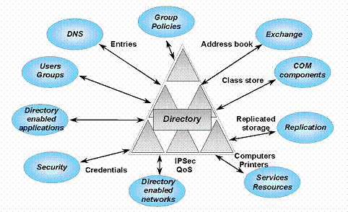
Upgrading hardware and software on site of SEI is an urgent need that should eliminate security problems and provide storage capacity for inspectors. It is suggested to cover storage and security issues with at least the following hardware. If the model will be on premises all necessary infrastructure MUST be installed in the server room of SEI with proper security, cooling and additional UPS, additional internet leased line with adequate capacity. Recommendations for hardware and software improvements are:
- Ram memory upgrade up to 256gb per server.
- Storage Disk upgrade with SAS disks 15k up to 4TB.
- SEIA OS version upgrade to Server 2012 R2 Datacenter.
- Upgrade all WMs to 2012R2 standard and raise functional level of domain/forest.
- Upgrade to SQL Server Standard 2014R2 for DB1 server.
- SharePoint upgrade to 2016 version and full application migration of BPMS.
- Implementation of Exchange Server 2016 and migration from current (lotus notes) version.
- Migration of SEI portal on additional VM in SEI organization.
- Implementation of advanced firewall for all published rules for sites and protocols.
- Configuring Hyper-V servers in Failover cluster with upgraded shared storage.
- Deploying Backup software solution for all servers with offsite copy backup.
- Configuring Disaster Recovery solution in Cloud.
- Implementing Antivirus/Antispam solution for all computers and users.
- Upgrading server room functionality with adequate cooling unit, UPS and entrance control.
In the future it should be assessed the needs for equipment for new inspectors or new organizational units, also planning to cover inadequate or old equipment that may be unable to run the upgraded BPMS.
It is necessary as well to plan additional licenses for covering connections to servers including BPMS and for office usage for inspectors.
- Hybrid model
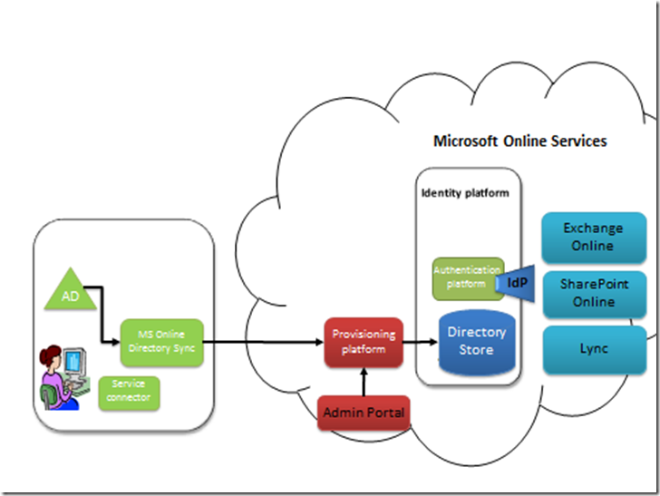

This model can be used only if it is possible to ensure adequate capacity for internet connection of SEI branch offices.
Usage of BPMS will be more useful if the inspectors are able to interact with the BPMS in the field, using mobile devices that can be more easily introduced in this hybrid model (number of licences, CAL, etc.), as shown below:
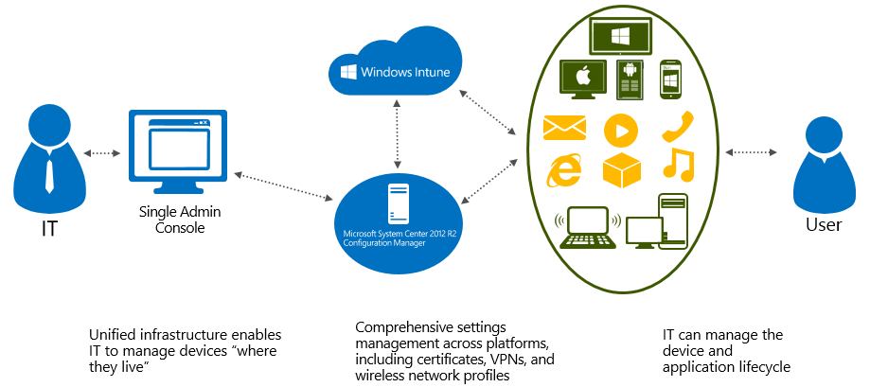

Summary and main conclusions
For follow-up stages it is necessary to ensure substantial hardware and OS upgrade, and also upgraded software to establish on a new platform an upgraded version of the application that can solve the gaps described in this chapter 4, such as Gantt diagram, editing pdf, etc.
Also, for the maintenance of the system, SEI must ensure outsourcing at least until SEI incorporates in its staff a full-time IT specialist (see section 4.4).
The follow-up actions can be divided into two phases, each of them including a supply contract for equipment, and always ensuring that all BPMS data can be constantly available in a secure environment.
Finally, it is recommended for the follow-up to give access to relevant staff from local authorities, in particular local authorised environmental inspectors, giving them possibility to use the BPMS. If in next stages a large number of new users is expected, a proper (larger) capacity and technical specifications must be ensured, to ensure a proper functioning of the BPMS.

National best practice to follow: Food and Veterinary Agency
The Macedonian Food and Veterinary Agency has developed in the last years (and is still developing) a software to support the work of the staff of the Agency, including their inspectors, which, according to discussions held in a meeting with staff of that Agency, seem to be in line with EU best practices. Thus, it is recommended to SEI to keep in close contact with this Agency, in order to learn from their experience and software.

Proposals on the way to upgrade the BPMS in the middle and long term
For middle-term upgrade, it must be considered that the BPMS tool is a very good tool for projects/environmental inspections management, but it is not prepared for elaborating statistics and a scoreboard. And this is an important issue, because it is difficult to manage what one cannot measure. This is the reason why the EU IMPEL network promotes the use of performance monitoring in the environmental inspections activity.
Moreover, the requirements linked to inspections to IED installations, as prescribed in the IED, call for a series of features currently absent in the BPMS (see section 4.3). In addition, the frequent updates in the national environmental legislation due to local circumstances and to the still ongoing alignment with EU acquis will require updates in the BPMS with a certain periodicity.
Taking this into account, and in general the gaps stated in section 4, it is considered as optimum to have both one/two supply contracts, to provide the necessary hardware, plus one/two service contracts, to develop the software tool, including a complementary database in which all the data obtained through the usage of electronic check-lists and the conclusions from the inspections reports (see e.g. section 4.2.2), could be processed, enabling the users to obtain indicators and graphics about the inspection activity and about the environmental behavior of the installations being subject to inspections. When preparing the Terms of Reference and specifications for such a software, an obligatory reference must be the report “Development of Macedonian National Environmental Information System Plan", in particular pages 15 till 28.
Nevertheless, according to the information provided by MoEPP IPA Unit, no service contract is scheduled in the IPA-2 programming period. Thus, some of the components related to software development proposed below might be developed within the Twinning contract described in section 6.2 of output “1.1.6-3.1.4_Potential-contents-follow-up-projects_160804_EN” (see end of that section) or be included as part of the scheduled supply contracts.
It should be considered if/which parts of the software development described below may be better transferred to the Twinning described in section 6.2 of output “1.1.6-3.1.4_Potential-contents-follow-up-projects_160804_EN”.
Besides, it must be mentioned that, depending on future decisions on the organisation of environmental inspection services in the country (e.g. centralisation or close cooperation between central and local inspectors), the hardware and software needs may change, and thus the following recommendations should be reviewed when the time comes to draft more detailed specifications, to ensure that they are adjusted to the reality of the situation in the Republic of Macedonia.
The same applies to the timing and contents of the supply contracts (depending on the final schedule for the tendering of the supply contracts, and on the supply priorities, the contents proposed below may have to be shifted to one supply contract or to the other).

First supply contract (implementation expected to start earliest 12/2018)
Within this 1-million € contract the following items are strongly recommended to be included in order to support SEI:

To take into account: proper linkage with external relevant databases
An important upgrade of the BPMS implies the capturing of data from external databases, and sharing some data with them, in particular those that may be in place in the MoEPP of relevance for the inspectors (E-PRTR, cadaster of installations, GIS, IPPC-A permits, waste permits, water-related permits…). It is considered essential to establish a connecting element for the different environmental information systems that will be developed by the SEI and the MoEPP, and to ensure proper linkage.
This must be taken into account when defining the ToR and related specifications.
For more info see sections 4.1, 4.2.1 & 4.2.3.

Additional hardware
When preparing technical specifications for the upgrading of the BPMS, it is suggested that they should include information about:
- The types of external databases that could/should be linked at that time (in operational or testing usage in that time)
- Number of expected inspectors from SEI, local entities and other institutions expected to be connected to the BPMS.
Another possible obstacle that should be considered and tried to be minimized is internet connections (broadband as services may be planned at least on main locations and in any case they will be needed for linkage with external databases).
Other aspects that should be considered when drafting the ToR are the following:
I Upgrading hardware and software on site of SEI is an urgent need that should eliminate security problems and provide storage capacity for inspectors. It is suggested to cover storage and security issues with at least the following hardware:
- Ram memory upgrade up to 256gb per server.
- Storage Disk upgrade with SAS disks 15k up to 4TB.
- SEIA OS version upgrade to Server 2012 R2 Datacentre.
- Upgrade all WMs to 2012R2 standard and raise functional level of domain/forest.
- Upgrade to SQL Server Standard 2014R2 for DB1 server.
- SharePoint upgrade to 2016 version and full application migration of BPMS.
- Implementation of Exchange Server 2016 and migration from current (lotus notes) version.
- Migration of SEI portal on additional VM in SEI organization.
- Implementation of advanced firewall for all published rules for sites and protocols.
- Configuring Hyper-V servers in Failover cluster with upgraded shared storage.
- Deploying Backup software solution for all servers with offsite copy backup.
- Configuring Disaster Recovery solution in Cloud.
- Implementing Antivirus/Antispam solution for all computers and users
- Upgrading server room functionality with adequate cooling unit, UPS and entrance control
II Upgrading hardware and software on users’ locations
In the future it should be assessed the needs for equipment for new inspectors or new organizational units, also planning to cover inadequate or old equipment that may be unable to run the upgraded BPMS.
It is necessary as well to plan additional licenses for covering connections to servers including BPMS and for office usage for inspectors.
III Upgrading software functionality of BPMS vs maintenance
Upgrading software must take in consideration that is necessary to have a corresponding upgrade of the maintenance, security and disaster recovery aspects. Part of these issues can be solved by using “cloud” possibilities (see point IV). It must be kept in mind that at least for the time being SEI does not have an IT unit or expert in its staff that can cover their needs for maintenance (from the solution of less complicated errors to the administration for servers or to ensure security for data stored in the BPMS).
IV Ensuring data security, protection and adequate storage capacity through the cloud
A preliminary suggestion is to use cloud possibilities (only applicable if it is possible to ensure broadband internet connectivity for main SEI location and also to connection to other databases and SEI branch offices).
According to EU legislation on security and data storage in the cloud, SEI may contract Microsoft for ensuring storage, disaster recovery and backup for its needs, paying as a result less for maintenance and avoiding most maintenance problems and the need every 2-3-year to buy additional hardware for storing data.
This option should be as shown on the figure below:

In any case, when the time comes to draft the ToR, the hardware should be defined in the ToR with adequate technical specifications, having as reference the newest devices on the market.

Upgrading of software
It should be considered when defining the ToR:
- Additional law enforcement needs
- Covering linkage with cadastre for GIS localization for preparation future inspections
- Linkage to external databases that can be in that time frame operational, testing phase or preparing through web services using adequate schemas for exchanging data.

The upgrading of the software should include the following aspects:
- Inclusion of more templates and possibility of generating more reports to support inspectors and managers. Definition of reports required to be generated (due to EU & national legal obligations)
  - It is recommended to use templates prepared within this Twinning project for final inspection report and publicly available inspection report (among others).
For more info see sections 4.2.2, 4.2.9 & 4.2.10.
- Ensure more access to info about inspections to all users (following recommendations in section 4.2.5).

- Develop additional IT tools in BPMS to help users (short explanatory movie, pop-up windows...)
For more info see section 4.2.5.
- Expand the BPMS module for assisting in the preparation of the annual inspection programme, taking into account (i) the risk score of each installation subject to inspection (obtained through IRAM), (ii) the last time that each installation has been inspected, (iii) any priorities derived from MoEPP’s policies or due to changes in legislation.
For more info see section 4.2.11.

- Give possibility to BPMS to send reminders to inspectors about pending tasks related to inspections that they have been assigned (for more info see section 4.2.11).

- Adaptations to ensure proper implementation of IED inspections (part of the adaptation can be delayed and included as part of the second supply contract)
For more info see section 4.3.

Second supply contract (implementation expected to start earliest 12/2019)
Within this 0.8-million € contract the following items are strongly recommended to be included in order to support SEI:

To take into account: proper linkage with external relevant databases
See the same comment made for the first supply contract.
Proper linkage with external relevant databases must be taken into account when defining the ToR and related specifications.
For more info see sections 4.1, 4.2.1 & 4.2.3.

Additional hardware
Depending on the hardware already acquired through the first supply contract, and the pending software functionalities to be included, the needs for further hardware should be defined. In any case it is recommended to include a few devices such as:
- storage with enough space for a few years of activity
- upgraded system hardware with adequate hard disk, RAM and networking connection
- additional power supply unit and cooling unit
- devices for monitoring and security
- software for monitoring and maintenance
- adequate devices for antivirus and antispam with networking and web part
In any case, when the time comes to draft the ToR, the hardware should be defined in the ToR with adequate technical specifications, having as reference the newest devices on the market.

Upgrading of software
- Adaptations to ensure proper implementation of IED inspections (part of the adaptation can be delayed and included as part of the second supply contract)
For more info see section 4.3.

Annex 1: EU best practice: general information management system & IED inspection software in Galicia (Spain)

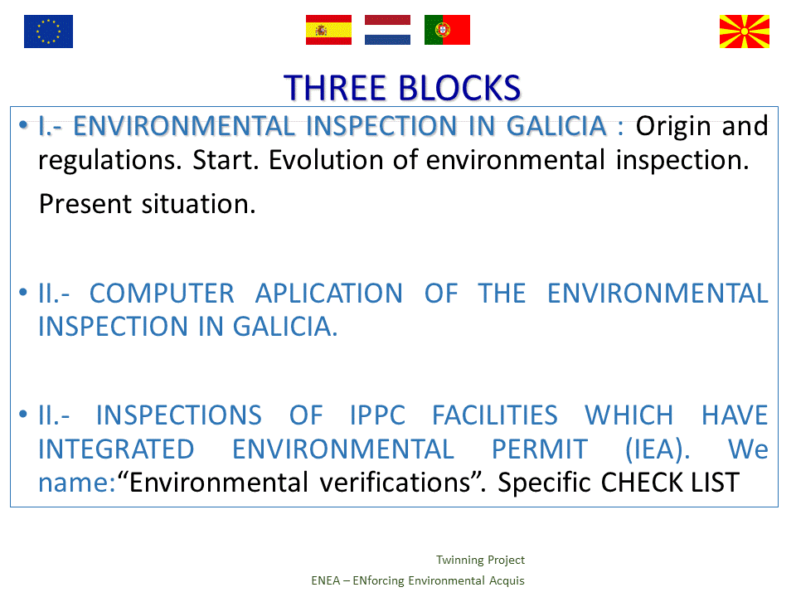
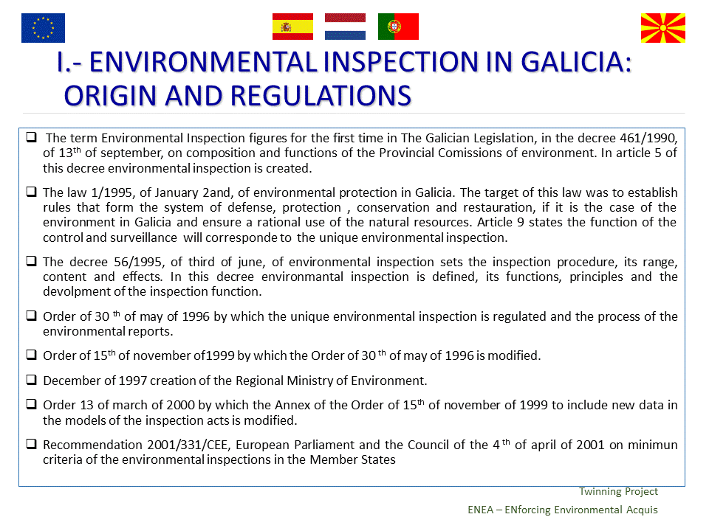
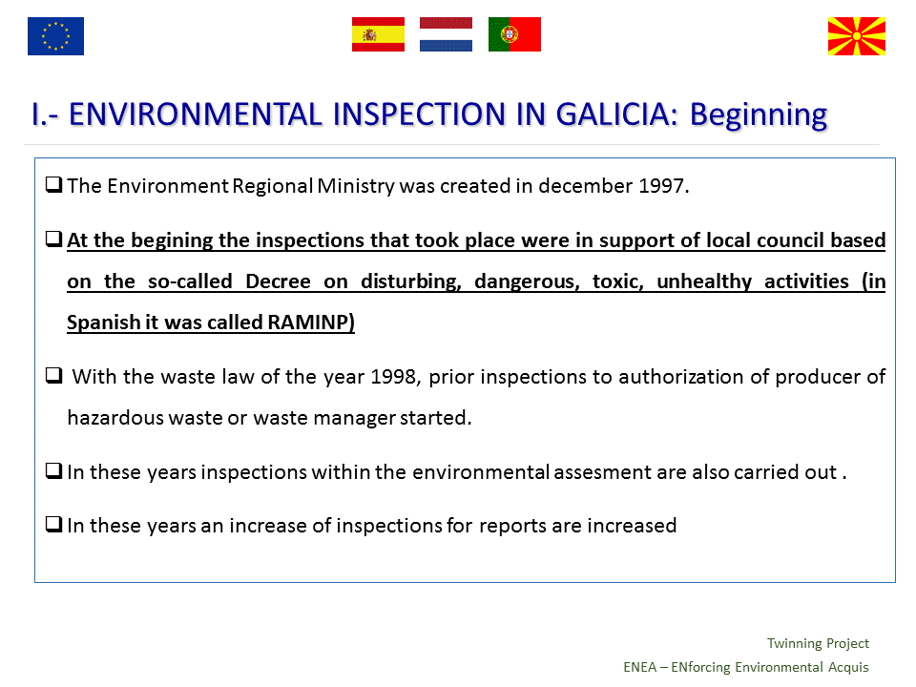
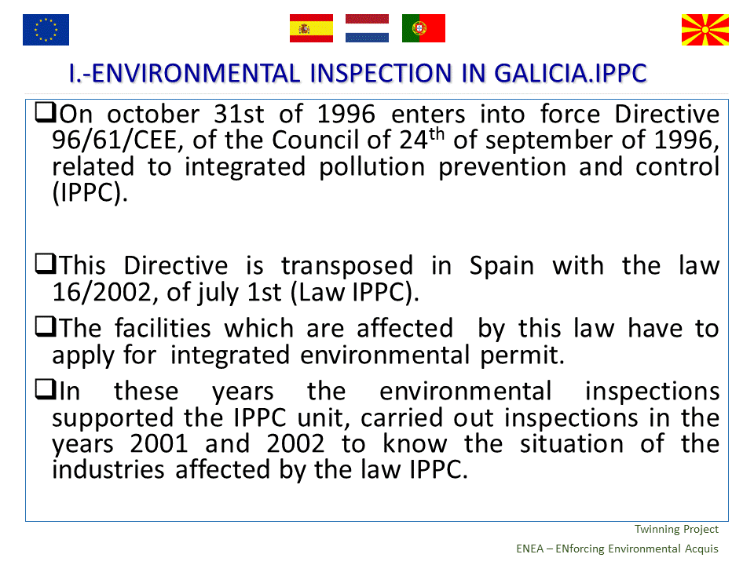
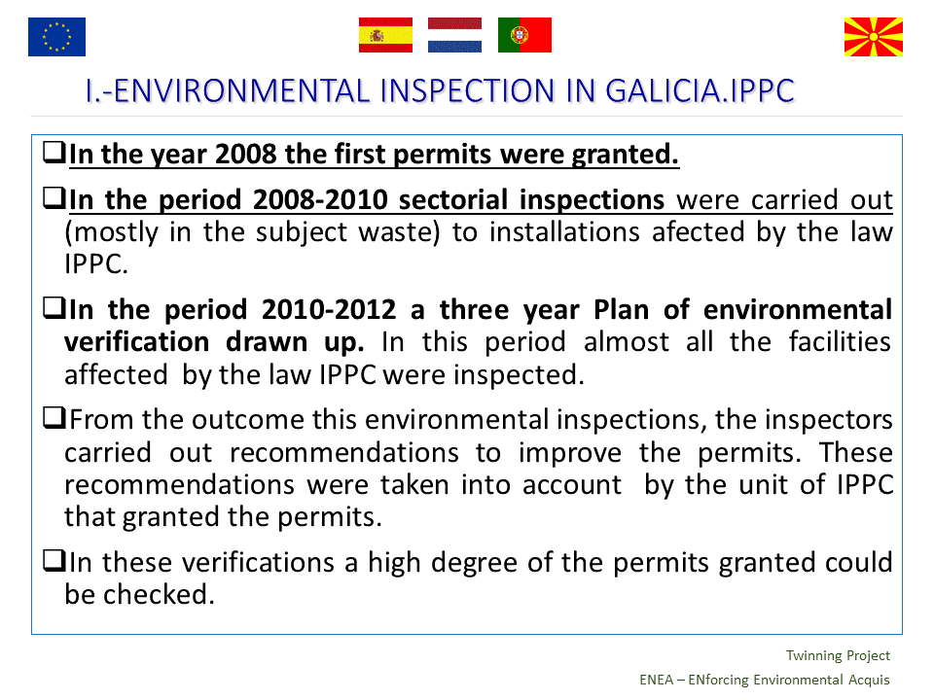
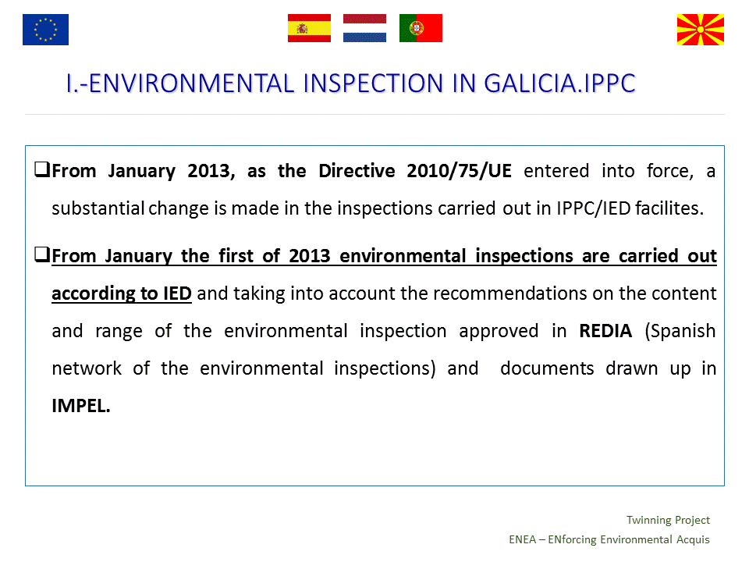
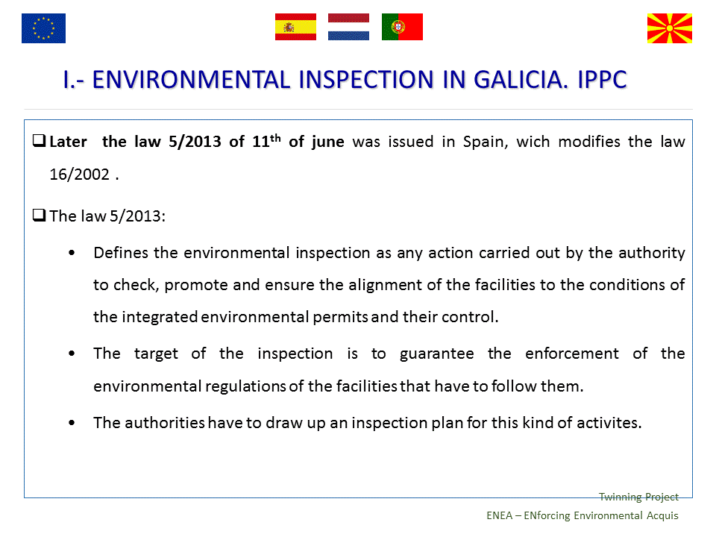
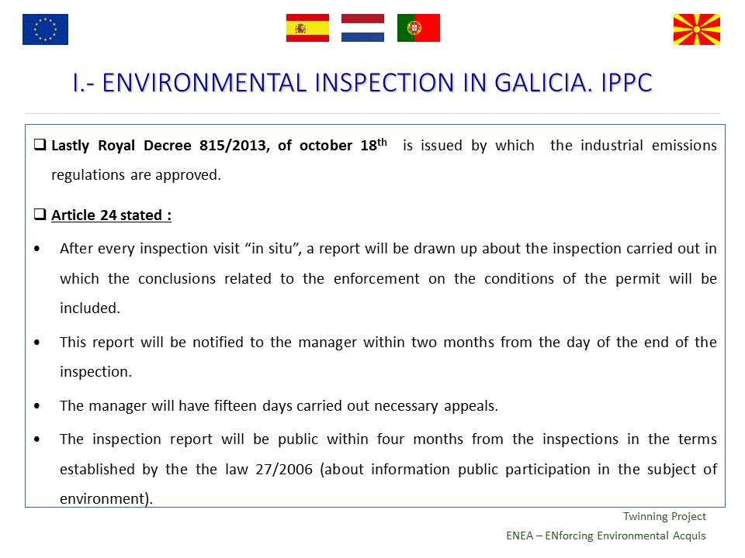
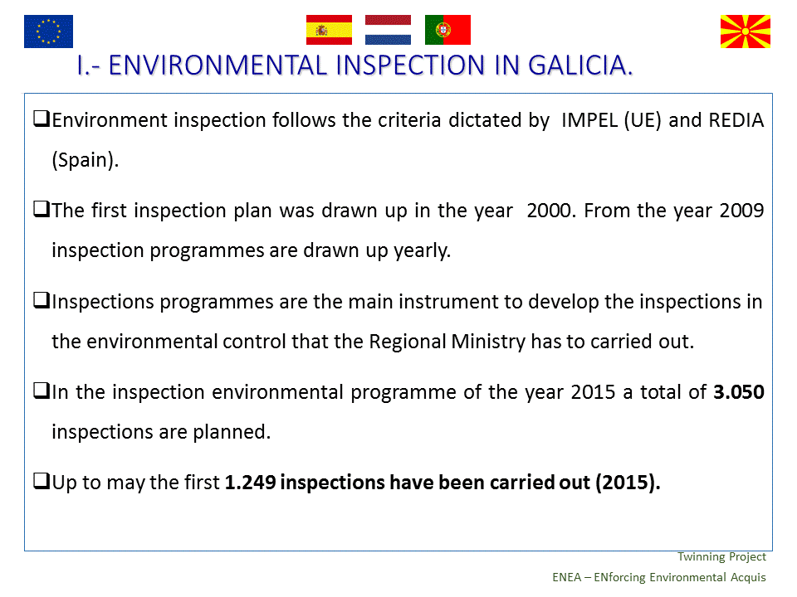
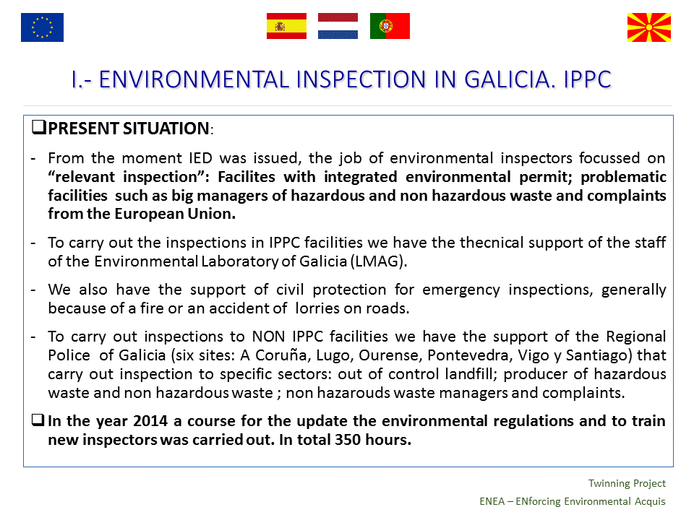
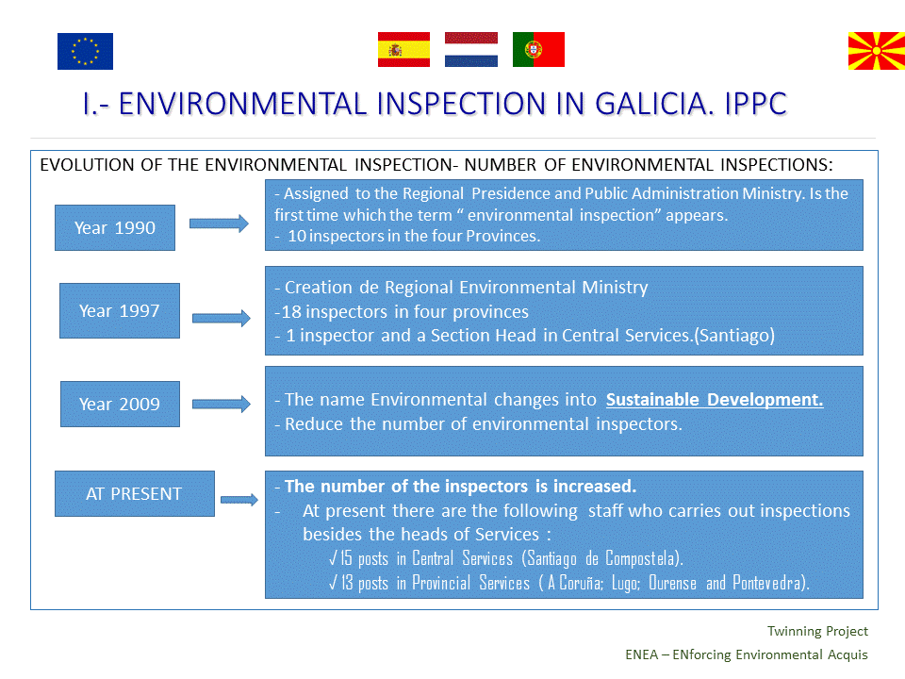
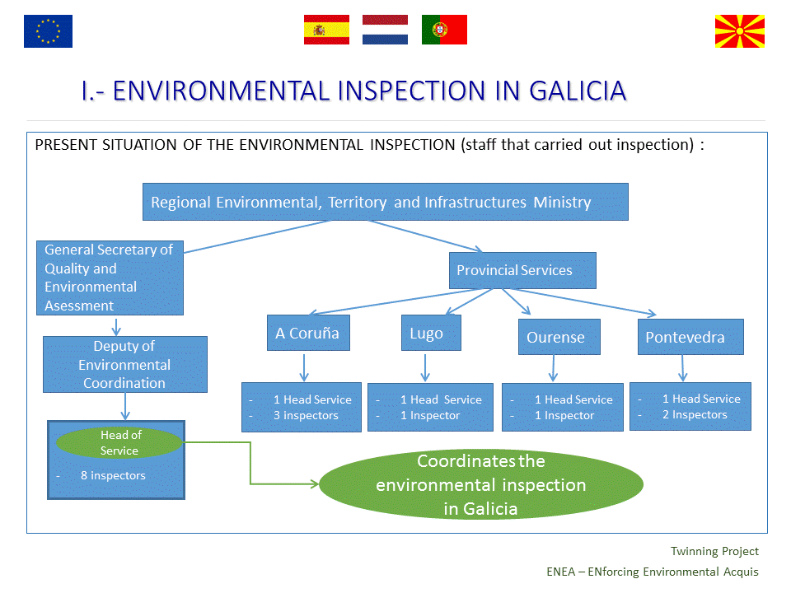
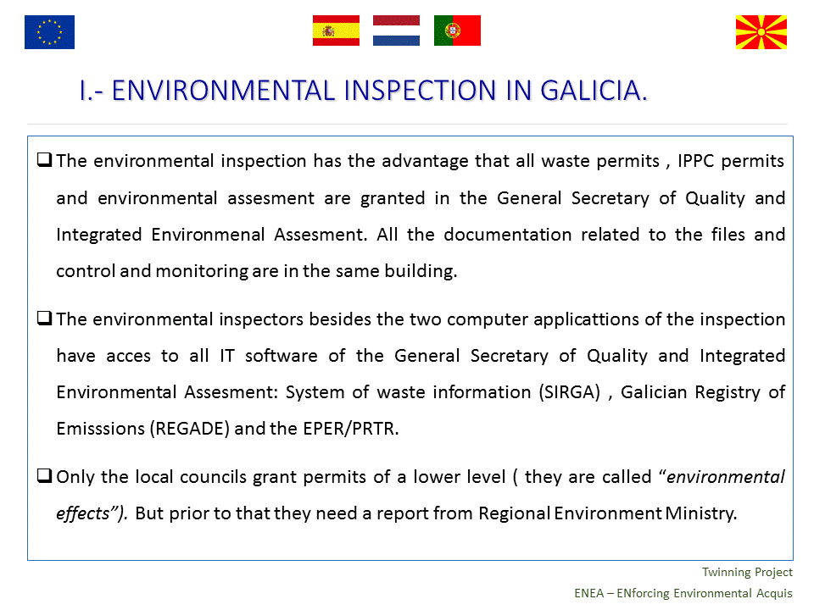
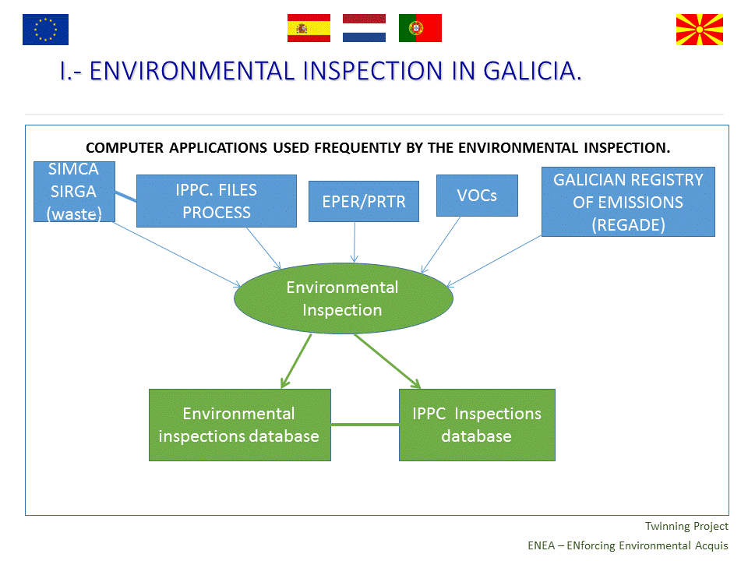
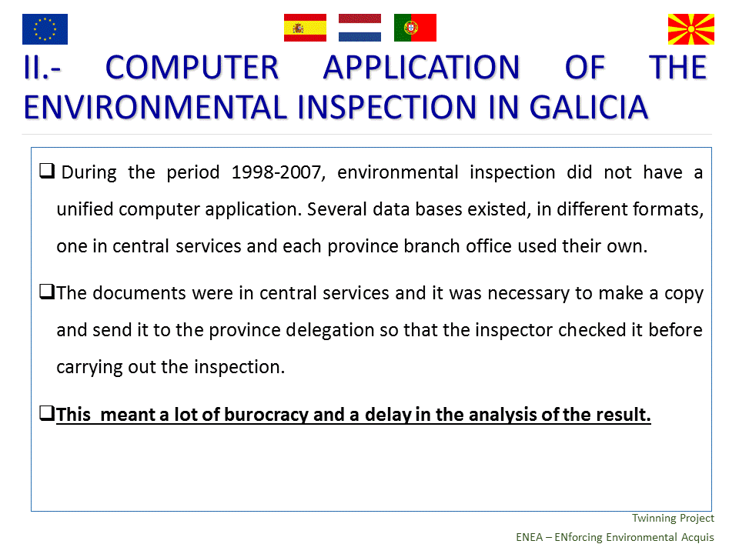
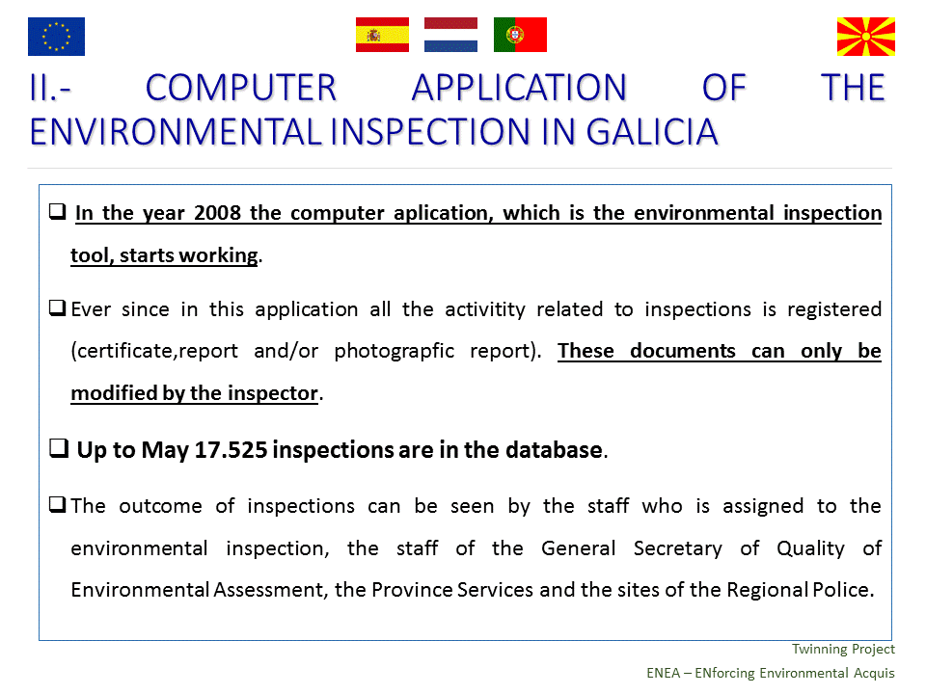
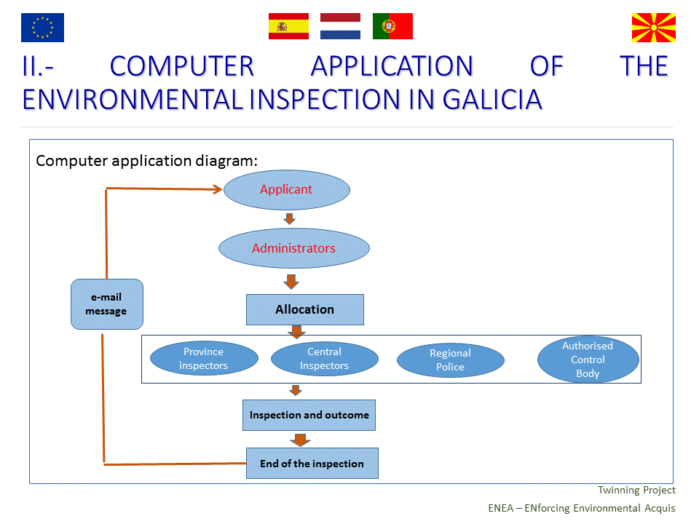
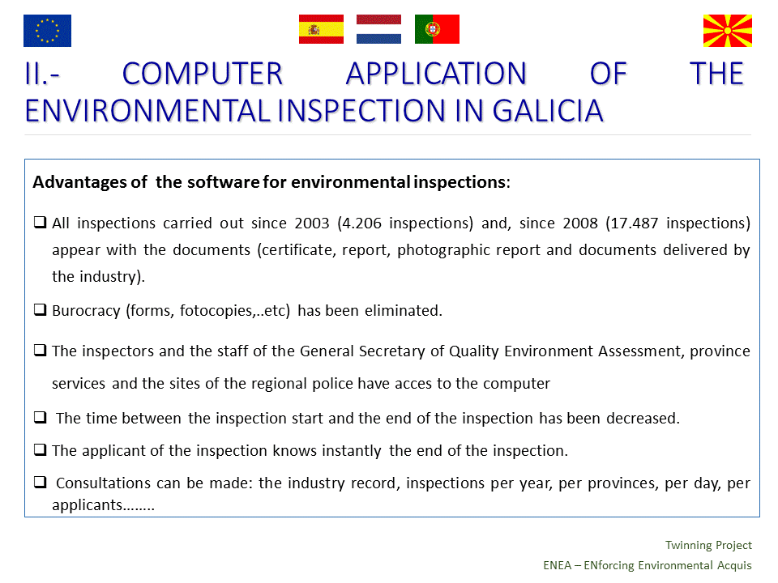
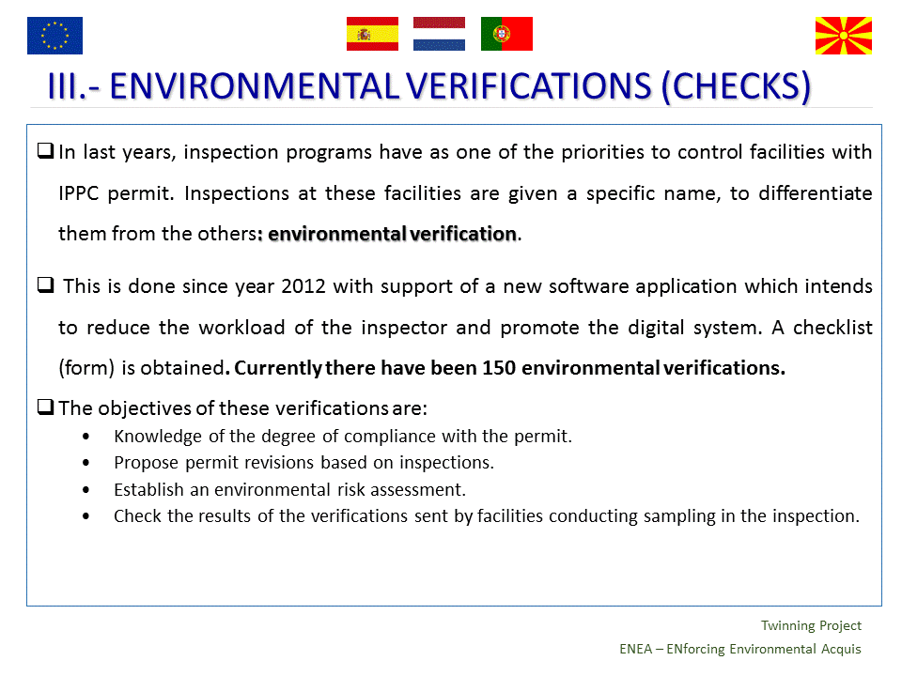
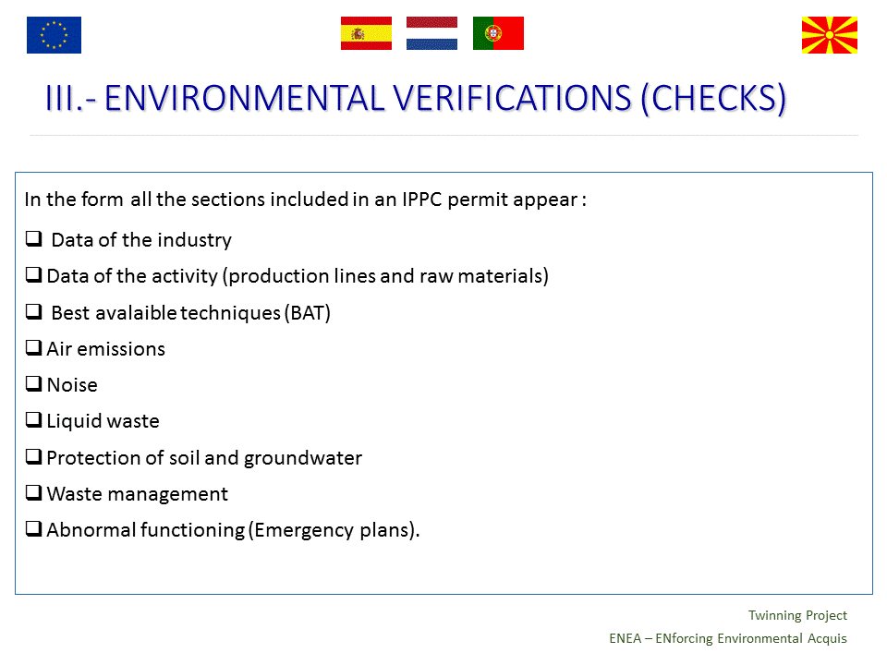
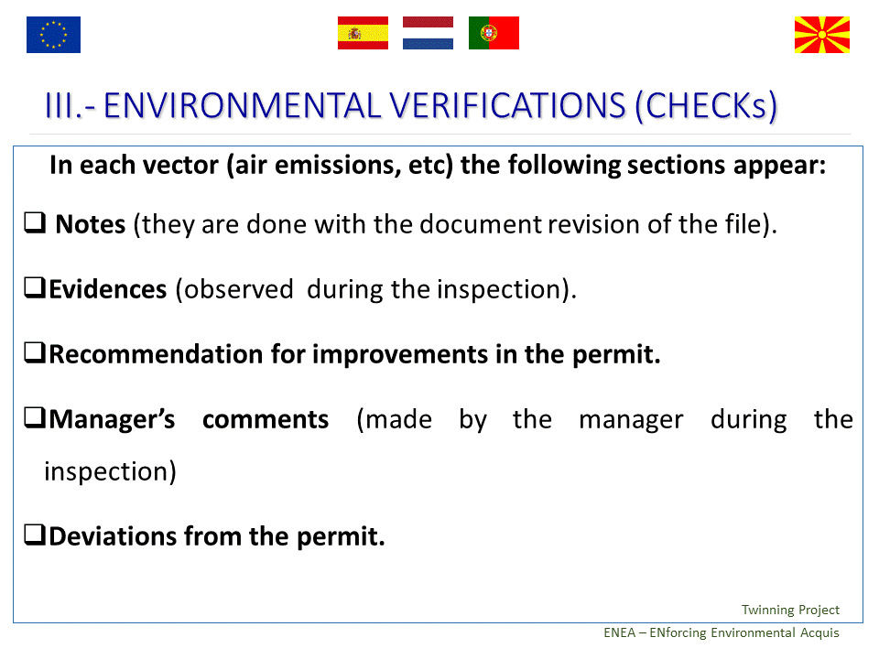
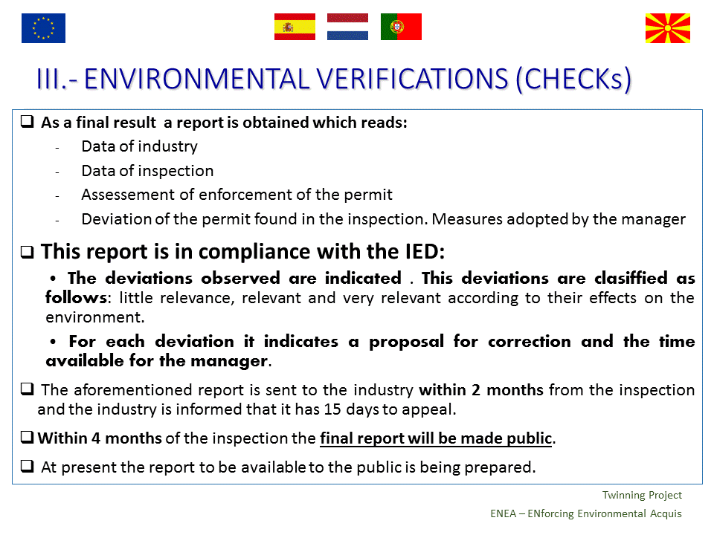
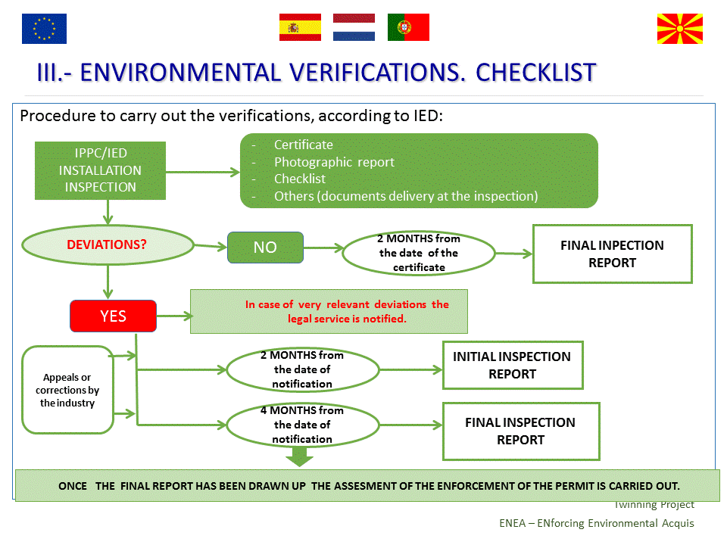
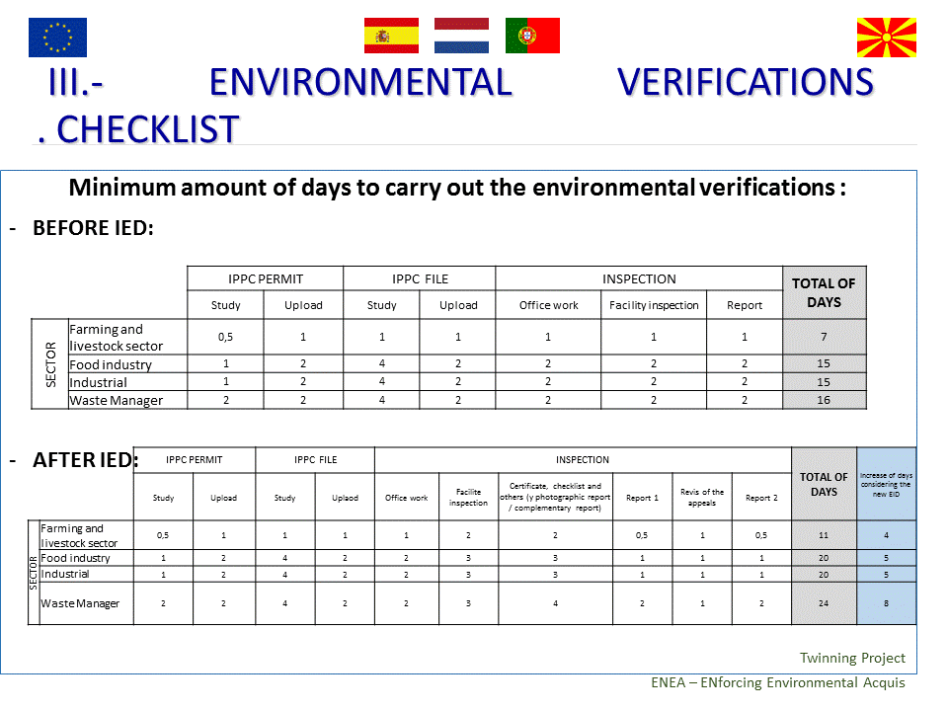
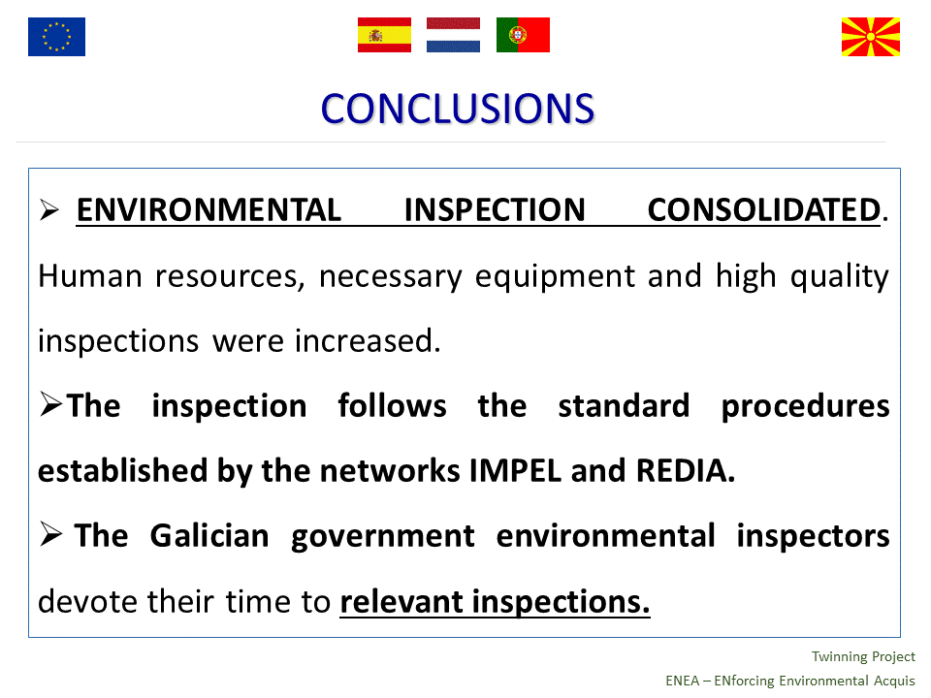

Annex 2: Screenshots of BPMS, showing some of its functionalities and suggesting (in red) some improvements
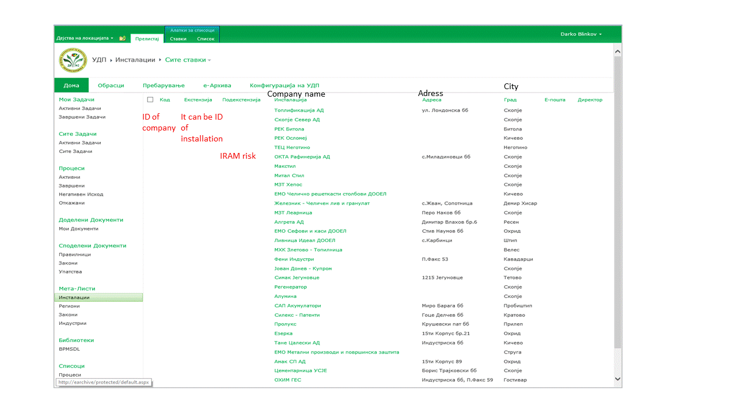
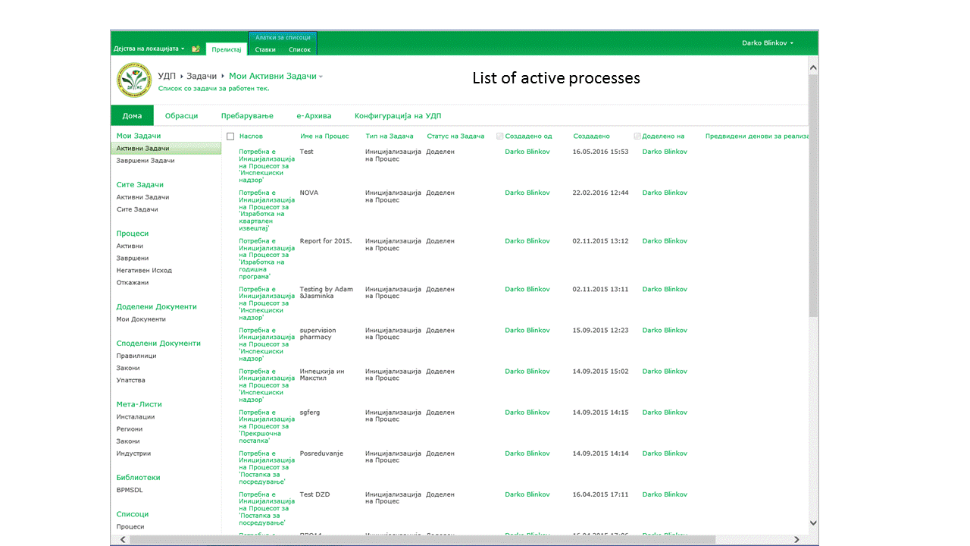
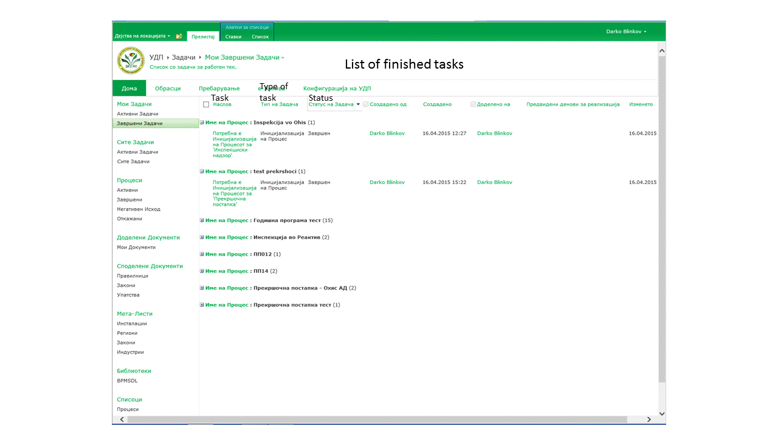
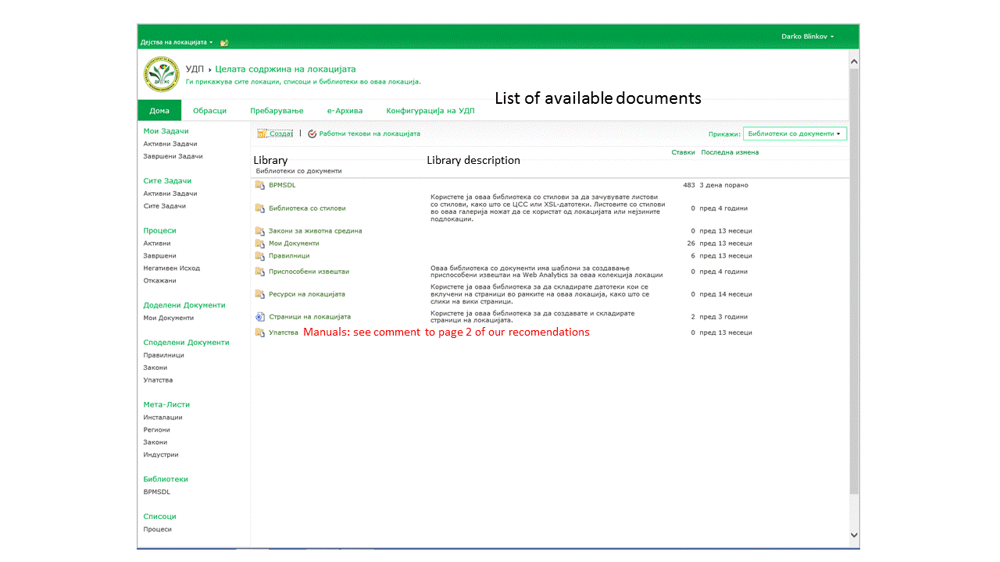
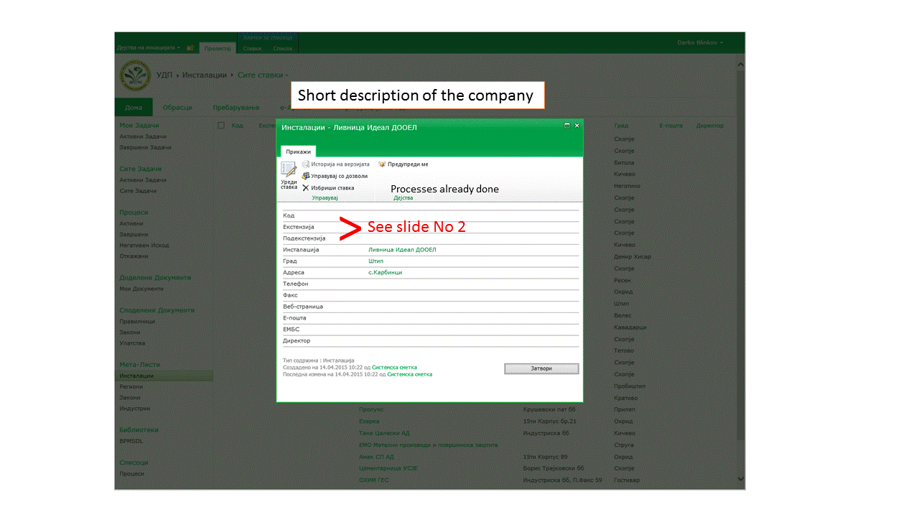
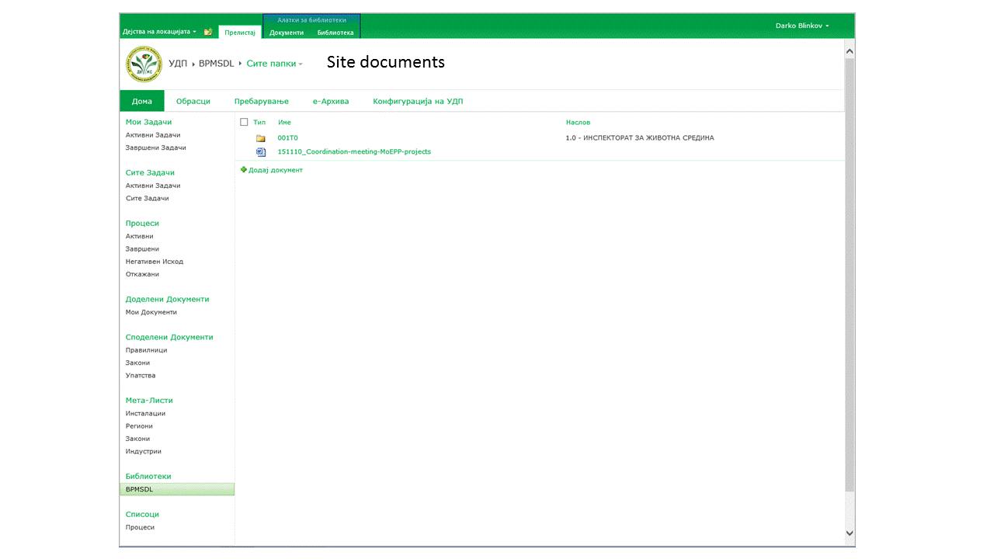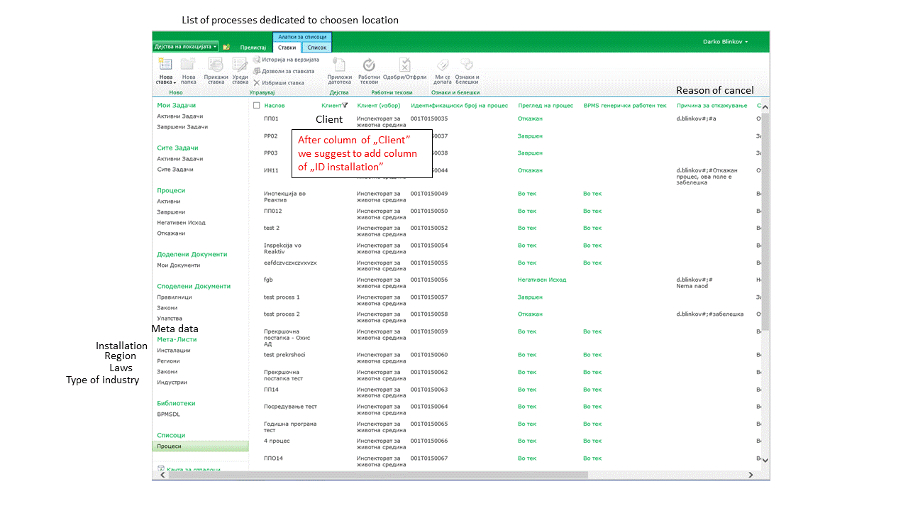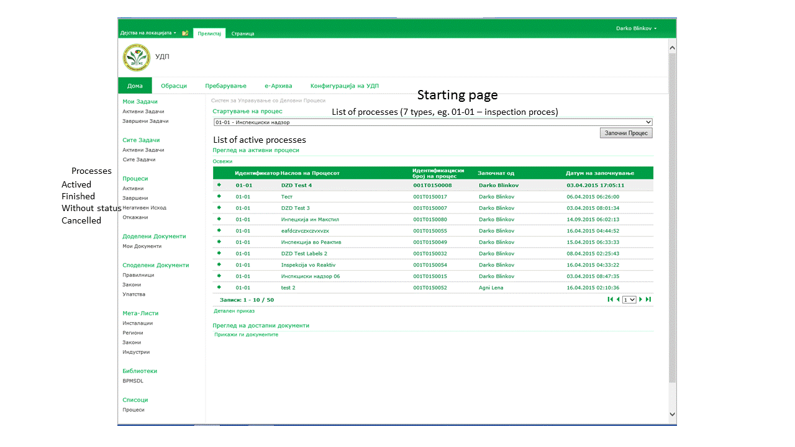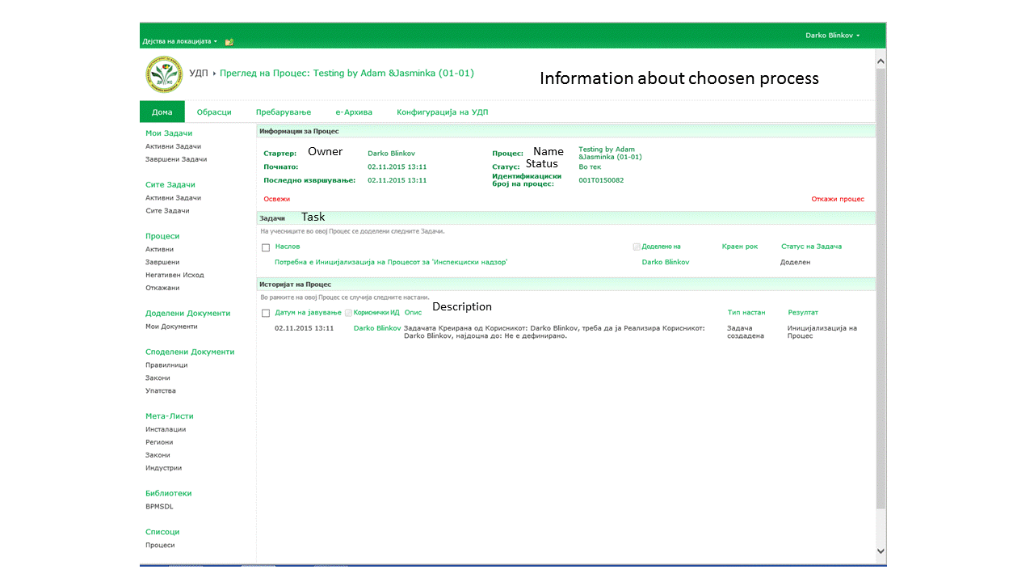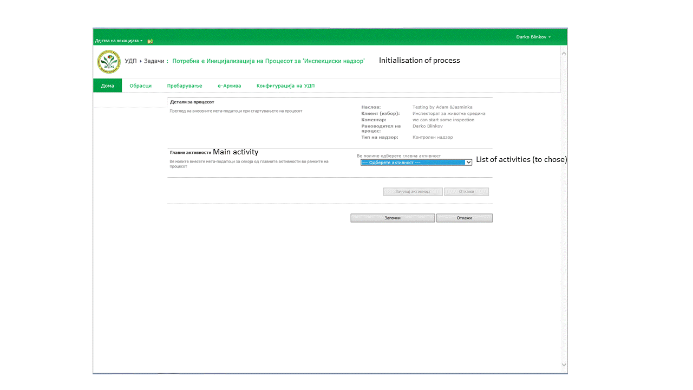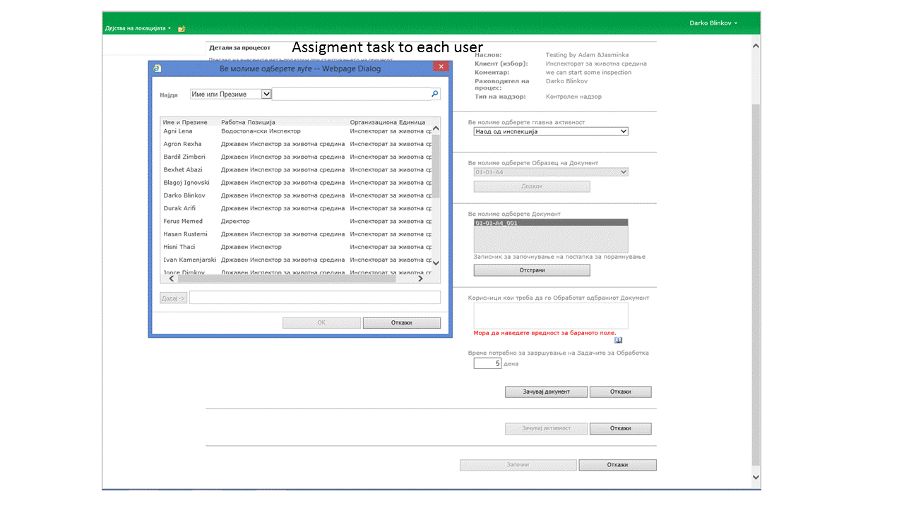

Annex 3: Example of Croatian internal guidance of the Ministry of Culture for the definition of specifications in IT maintenance contracts
Prijedlog za natječaj za održavanje
sistemske, mrežne i sw, hw infrastrukture MK i konzervatorskih odjela
I OPĆI UVJETI
- U okviru svakodnevnih poslovnih potreba Ministarstva kulture i konzervatorskih odjela ( 25 lokacije pregled i adrese lokacija nalaze se na web stranicama Ministarstva kulture : http://www.min-kulture.hr/default.aspx?id=172 ) potrebno je osigurati neprekidnost odvijanja poslovnih procesa i dostupnost web portala, uključujući sistemsko serverski i mrežno-komunikacijskog podsustav uz održavanja primjenjujući odgovarajući odziv na primljenu prijavu kvara ili neispravnosti.

Dokument u kojem se nalazi pregled infrastrukture i poslovnih definicija pojedinog servera je dostupan za one koji budu izabrani u uži izbor.*

- Stalni 365/7/24 nadzor domene koju sačinjava hardverska oprema, sistemski i aplikativni software, sustav za pohranu, mrežno-komunikacijska infrastruktura i sigurnosni nadzor DMZ okoline domene MK prema definiranim vremenima odziva u slučaju prijave problema, greške, zastoja, havarije od strane ovlaštene/ih osoba iz MK. Vremena odziva su definirana prema SLA proceduri od 30 minuta do drugi radni dan.

- Osiguravanje funkcioniranja sustava za evidenciju radnog vremena koji je instaliran na svim lokacijama i bez kontaktnim karticama osigurava prijavu i evidenciju radnog vremena djelatnika Ministarstva kulture.

- Sukladno opisu poslovnih potreba MK i konzervatorskih odjela potrebno je osigurati da:
Ponuditelj ili zajednica ponuditelja da ima bonitet sukladno naputcima Ministarstva financija, Ministarstva uprave i DSUJN , te da može ili mogu osigurati da je usluga održavanja (SLA) dostupna od 30 minuta za kritičnu situaciju, do drugi dan za probleme u radu na lokacijama izvan Zagreba, te se traži osiguravanje suradnika na terenu pod istim uvjetima kao i u Zagrebu za rješavanje osnovnih harwareskih kvarova. Tvrtka ponuđač ili zajednica ponuditelja mora dokazati da ima skladište sa dijelovima za opremu prema našim potrebama.

- Ponuditelj ili zajednica ponuditelja mora dokazati i slijedeće stručne kompetencije:

- Popis značajnijih ugovora ponuditelja o pružanju usluga koje su predmet ove nabave, a koje je ponuditelj pružao drugim ugovornim stranama (naručiteljima) u posljednje 3 godine (minimalno 3 ugovora).

- Potvrde svih naručitelja iz popisa ugovora izdane od strane naručitelja iz prethodne točke, o uredno izvršenim ugovornim obvezama koje trebaju sadržavati: naziv i sjedište ugovornih strana, predmet ugovora, vrijednost ugovora, vrijeme i mjesto ispunjenja ugovora, te navod o uredno ispunjenim ugovorima.

- Izjavu ponuditelja ili zajednice ponuditelja o prosječnom godišnjem broju radnika u posljednje 3 godine.

- Izjavu ponuditelja o organiziranoj servisnoj mreži s popisom lokacija (mjesta u RH) u kojima ponuditelj ima vlastita servisna predstavništva, odnosno podružnice s adresama, brojevima telefona i telefaksa.

- Izjavu ponuditelja o broju zaposlenih servisera po vlastitim servisnim lokacijama iz prethodne točke iz koje je vidljivo da ponuditelj ima minimalno 25 zaposlenih servisera.

    - Izjavu ponuditelja o dijelu ugovora koji namjerava ustupiti proizvoditeljima (opisno, te izraženo u postotku od ukupne vrijednosti ponude) sa podacima o proizvoditelju, odnosno proizvoditeljima ako ih je više, s naglaskom da isti ne smiju prelaziti više od 30 posto ukupnog iznosa ponude.

    - Izjava ponuditelja s popisom opreme iz kojih je vidljivo da ponuditelj na skladištu ima najmanje 500.000,00 kn vrijednosti opreme i rezervnih dijelova vezanih za pružanje usluga koje su predmet nabave.

    - Potvrdu izdanu od strane ovlaštenog ureda u RH proizvođača Microsoft programske opreme da ponuditelj ima status Microsoft Gold Partnera.

    - Potvrdu izdanu od strane ovlaštenog ureda u RH proizvođača mrežne opreme Cisco Systems da ponuditelj ima status Cisco Gold Partnera.

    - Potvrdu izdanu od strane ovlaštenog ureda u RH proizvođača informatičke opreme IBM da ponuditelj ima status IBM Premier ili veći

    - Potvrdu izdanu od strane ovlaštenog ureda u RH proizvođača informatičke opreme Palo Alto da ponuditelj ima status Silver ili veći

    - Potvrdu izdanu od strane ovlaštenog ureda u RH proizvođača informatičke opreme Fortinet o da ponuditelj ima status Silver ili veći

    - Potvrdu izdanu od strane ovlaštenog distributera u RH za Fingerscan Identix opremu i softvera da je ponuditelj osposobljen i ovlašten za održavanje Fingerscan Identix sustava za evidenciju radnog vremena.

    - Dokazi, stručni certifikati s dokazom o zaposlenju iz kojeg je vidljivo da ponuditelj ima u stalnom radnom odnosu stručne osobe za održavanje predmeta nabave pri čemu jedna osoba može biti nositelj više certifikata:

- Najmanje 2 osobe sa certifikatima za HP poslužitelje i HP Storage.
- Najmanje 2 osobe sa certifikatima za IBM Certified Specialist - Midrange Storage Technical Support V3,
- Najmanje 5 osoba sa certifikatom Cisco CCIE
- Najmanje 2 osobe sa Palo Alto certifikatom Accredited Configuration Engineer i najmanje 1 osoba sa Certified Network Security Engineer
- Najmanje 2 osobe sa Fortinet Certified Network Security Administor i najmanje 2 osobe sa Fortinet Certified Network Security Professional
- Najmanje 3 osobe sa ITIL Foundation certifikatom.
- Najmanje 2 osobe sa Project Management Professional
- Najmanje 2 osobe sa certifikatima za IBM/Lenovo Blade poslužitelje.

Dokazi, osobni stručni certifikati s dokazom o zaposlenju iz kojeg je vidljivo da ponuditelj ima u stalnom radnom odnosu stručne osoba za implementaciju i održavanje predmeta nabave sa dolje navedenim certifikatima, pri čemu jedna osoba može biti nositelj više certifikata:

- Najmanje 5 certifikata za Microsoft Certified Systems Administrator
- Najmanje 5 certifikata za Microsoft Certified Systems Engineer
- Najmanje 3 certifikata za Microsoft Certified Database Administrator

    - Dokazi, osobni stručni certifikati s dokazom o zaposlenju iz kojeg je vidljivo da ponuditelj ima u stalnom radnom odnosu stručne osoba iz područja sigurnosti predmeta nabave sa dolje navedenim certifikatima, pri čemu jedna osoba može biti nositelj više certifikata:

- Najmanje 2 certifikata za Certified Information Security Auditor
- Najmanje 2 certifikata za Certified Information Security Manager
- Najmanje 2 certifikata za Certified Information Security Systems Professional

    - Izjavu ponuditelja da ima vlastitu HelpDesk/ServisDesk službu s navedenim brojevima telefona i telefaks, e-maila i Web stranice za prijavu kvara i problema u radu opreme koja je predmet održavanja.

    - Izjava ponuditelja o sukladnosti s normom osiguranja kvalitete HRN EN ISO 9001:2009 i s normom za sustav upravljanja informacijskom sigurnošću HRN ISO/IEC 27001:2006, ili njima odgovarajućim ili novijim, minimalno za djelatnost održavanja strojne i programske opreme, te za svaki od servisa iz servisne mreže navedenih na Izjavi o organiziranoj servisnoj mreži. Uz Izjavu gospodarski subjekt je dužan priložiti presliku spomenutih certifikata.

II. SPECIFIKACIJA OPREME KOJA JE PREDMET ODRŽAVANJA
I POTREBNIH USLUGA ODRŽAVANJA

- INFORMACIJSKI SUSTAV U FUNKCIJI POSLOVNE PODRŠKE

Podaci unutar poslovnih procesa Ministarstva kulture se koriste za obavljanje upravnih, poslovnih, te pravnih i zakonskih obveza, zatim za izradu analitičko-statističkih izvješća i imaju dnevnu ažurnost zbog čega postoji potreba održavanja centralnog dijela sustava u punoj funkcionalnosti 24 sata dnevno uz visoku operativnost, odnosno minimizirano vrijeme izvan rada i dostupnosti sustava kako na lokaciji u Zagrebu, tako i na lokacijama izvan Zagreba.
- OPIS INFORMATIČKE OPREME

Budući da je predmet pružanja usluga održavanja informatičkog sustava naručitelja, ponuditelji neće biti vrednovani kroz količinu instalirane informatičke opreme, već kroz cijenu, vrstu i količinu utrošenih radnih sati na održavanju opreme i to kako sistemske, tako i aplikativne podrške, te perifernih i komunikacijskih uređaja. Stoga su u nastavku dokumentacije specificirani tip i vrsta instalirane serverske, komunikacijske, računalne i programske opreme s okvirnim količinama jer su količine promjenjive tijekom razdoblja održavanja, radi uobičajene zamjene, rashodovanja, nova nabava i neuvjetovanih hitnih potreba.

  - Računalna oprema

Informatička oprema instalirana u informacijskom sustavu Ministarstva je tipa PC opreme – serveri, radne stanice, prijenosna računala i periferna oprema.
U zgradi Ministarstva instalirano je 36 fizičkih i 64 virtualnih poslužitelja . Na istoj lokaciji nalazi se i sustav pohrane podataka, te blade servera u dvije šasije IBM I HP. Ukupno je instalirano preko 420 računala ( na svim lokacijama ministarstva) nabavljani javnom nabavom i većinom su HP i IBM proizvođača, zatim 40-tak grafičkih radnih stanica, a za potrebe terenskog rada, koristi se još i 80-tak prijenosnih računala. Za ispis se koriste matrični pisači tipa Epson, laserski pisači tipa XEROX, HP, Kyocera i Lexmark i tintni pisači HP, Canon i Epson. Za pohranu podataka koriste se trake*, te RAID5 diskovni sustav.
  - Mrežna oprema

U Ministarstvu je instalirana komunikacijska oprema, usmjerivačka (routing) oprema i preklopna (switching) oprema. Kao aktivna oprema koriste se oprema proizvođača Cisco iz serije 26xx. Također na lokacijama konzervatorskih odjela i ureda nalazi se komunikacijska i mrežna oprema uglavnom proizvođača CISCO iz serije 24xx.
  - Komunikacijska infrastruktura

Korisnici sustava na udaljenim lokacijama Konzervatorski odjeli u Bjelovaru, Dubrovniku na obje lokacije, Gospiću, Imotskom, Karlovcu, Krapini, Osijeku, Požegi, Puli, Rijeci, Sisku, Slavonskom Brodu, Splitu, Šibeniku, Trogiru, Varaždinu, Vukovaru, Zadru i Zagrebu na obje lokacije, te uredi u Korčuli, Poreču i Pakracu, pristupaju centralnom sustavu preko VPN mreže. Središnja lokacija ministarstva u Runjaninovoj 2 povezana je stalnim optičkim vodom sa davateljem Internetske veze brzinom , te posebnom optičkom linijom dedicirano za sve konzervatorske odjele.
  - Sustav za evidenciju radnog vremena

Sustav za evidenciju radnog vremena baziran je na Fingerscan Identix V70 uređajima za prepoznavanje bez kontaktnih kartica i mogućnost biometrijske metode prepoznavanja “otiska” prsta. Uz navedene uređaje, instaliran je mrežnim softveru FingerLan te Bone ID aplikativni softveru za evidenciju radnog vremena koje vode po ustrojstvenim jedinicama za to nadležni djelatnici/ce.

- SPECIFIKACIJA POTREBNIH USLUGA ODRŽAVANJA
Predmet ovog nadmetanja jest ustupanje usluga održavanja informatičke opreme, računalne mreže, komunikacijske opreme, sistemske i aplikativne programske podrške u funkciji rada informacijskog sustava Ministarstva kulture na lokacijama Runjaninova 2, Mesnička 27 i 49 te u svim Konzervatorskim odjelima u: Bjelovaru, Dubrovniku ( obje lokacije C. Zuzorić i Sv. Dominika), Gospiću, Imotskom, Karlovcu, Krapini, Osijeku, Požegi, Puli, Rijeci, Sisku, Slavonskom Brodu, Splitu, Šibeniku, Trogiru, Varaždinu, Vukovaru, Zadru i Zagrebu te uredima u Korčuli, Pakracu i Poreču.
Predmet nadmetanja također je održavanja sustav za evidenciju radnog vremena na svim lokacijama koje su navedene u točci 2.4. ove specifikacije, ali i održavanje opreme koja će se tijekom trajanja ugovora o održavanju dodatno nabaviti.
- Održavanje operativnog sustava računala, računalne mreže i informatičkog sustava Ministarstva kulture u ispravnom i funkcionalnom stanju.
- Održavanje računalne opreme informatičkog sustava Ministarstva kulture u ispravnom i funkcionalnom stanju.
- Održavanje dokumentacije o stanju sustava.
- Stalna suradnja s isporučiteljima održavanja ostalog aplikativnog softvera.
- Usuglašavanje plana održavanja s Naručiteljem.
- Redovno izvješćivanje Naručitelja o stanju sustava i poduzetim aktivnostima.

  - Od ponuditelja ili zajednice ponuditelja zahtijeva se :

3.1.1. usluge održavanja serverske osnovice:
a) održavanje MS Windows operacijskih sustava na poslužiteljima
b) održavanje infrastrukturnih mrežnih servisa (DNS, WINS, DHCP, NTP)
c) održavanje MS Exchange sustava elektroničke pošte
d) održavanje MS Active Directory-a
e) održavanje MS TMG, Fortigate, Palo Alto i Cisco ASA sustava za pristup Internetu
f) održavanje MS SQL baziranog sustava baze podataka, te SharePoint i BizzTalk okruženje
g) održavanje HP i IBM BLADE i STORAGE infrastrukture
h) održavanje sustava dijeljenja datoteka odnosno pisača
i) podešavanje i prilagođavanje sustava u skladu s potrebama i naputcima djelatnika Službe za informatizaciju i mrežne stranice Ministarstva kulture za rad poslovnih aplikacija
j) održavanje sustava za zaštitnu pohranu podataka (backup)
k) održavanje sustava antivirusne zaštite
l) testiranje sustava besprekidnog napajanja
m) izrada procedura i programa za automatizaciju i olakšavanje korištenja sustava
n) reinstalacija i podešavanje sistemskog softvera u slučaju zamjene poslužiteljske računarske opreme (npr. zamjena neispravnih diskova), odnosno nabave nove i prenamjene stare opreme
o) instalacija novih verzija poslužiteljskog sistemskog softvera
p) instaliranje i podešavanje novih servera i njihovih funkcija unutar informacijskog sustava Ministarstva kulture za potrebe poslovnog informacijskog sustava Ministarstva i konzervatorskih odjela.

    - usluge održavanja radnih stanica:
a) usluga podešavanja softvera na novim radnim stanicama – interaktivno ili definiranim automatiziranim procedurama
b) usluga podešavanja softvera nakon instalacija odnosno reinstalacija operacijskih sustava
c) usluga održavanja operacijskih sustava korisničkih računala
d) usluga podešavanja softvera na korisničkim radnim stanicama (e-mail, MS Office, i poslovne aplikacije koje se rabe u Ministarstvu kulture)
e) vođenje računa o pravilnoj nadogradnji zakrpa OS-a , i antivirusne zaštite
f) priključenje ostale opreme na radne stanice (pisači, CD snimači, skeneri, ...)
g) podrška korisnicima

    - usluge preventivnog održavanja sustava za evidenciju radnog vremena:
Održavanje svih instaliranih Fingrescan Identix uređaja za evidenciju radnog vremena na lokacijama iz točke 2.4. ove specifikacije, što uključuje radno vrijeme za:
- izrada i programiranje novih bez kontaktnih kartica
- dodavanje novih inačica softvera sa obukom korisnika

    - Ostale stručno tehničke usluge:
- ažuriranje tehničke dokumentacije o stanju sustava Ministarstva kulture
- kontrola mrežnog prometa korištenjem odgovarajućeg softverskog alata kojeg nabavlja Naručitelj
- poboljšanje parametara LAN/WAN mreže glede pouzdanosti, sigurnosti i zaštite
- konzultacije na razvoju i unapređenju mreže i primjeni novih softverskih proizvoda prema naputcima Službe za informatizaciju i mrežne stranice ministarstva
- izrada mjesečnog izvješća o intervencijama i promjenama na infrastrukturi informacijskog sustava
- ostali poslovi koji se odnose na cjelokupnu informatičku infrastrukturu prema naputcima
Službe
- primjena definirane sigurnosne politike (zaštita podataka, dostupnost podataka…) prema naputcima savjetnika za informacijsku sigurnost, kao i redovito praćenje i implementacija podataka vezanih za sigurnosnu politiku (security update, podešavanje serverskih i mrežnih proizvoda…)
- primjena backup procedura
- proaktivna usluge radi sprječavanja problema i povećanja raspoloživosti informacijskog sustava

3.2. Održavanje računalne opreme informatičkog sustava ministarstva u ispravnom i funkcionalnom stanju
Od ponuditelja ili zajednice ponuditelja zahtjeva se:
Servisiranje mrežnih poslužitelja, mrežne opreme, uređaja za pohranu podataka, radnih stanica, prijenosnih računala, UPS-ova i periferne opreme (pisači, skeneri, CD i DVD snimači, i sl.).
Servisiranje računala:
Prema dobivenom mailu iz MOSS sustava obavljanje popravka i evidentiranje ostalih uočenih problema i to: zamjena i podešavanje mrežnih kartica sa kompletnim prilagođavanjem na mrežu (domena, IP), zamjena grafičkih kartica i podešavanje parametara prema mogućnosti monitora, zamjena diskova, instalacija operacijskog sustava i svih korisničkih programa potrebnih za pravilno funkcioniranje radnog mjesta, izrada slike diskova sa operacijskim sustavom i osnovnim korisničkim programima za strojeve iste konfiguracije, zamjena perifernih USB jedinica i prilagodba njihovog rada, zamjena i podešavanje ostalih perifernih uređaja, zamjena i podešavanje uređaja za pohranu podataka na osobnim računalima.
Evidentiranje intervencija sa radnim nalozima potpisanim od strane korisnika i ovlaštene osobe.

Postupke održavanja i servisa potrebno je omogućiti kontinuirano, uz osiguranje stalne komunikacijske veze s Naručiteljem. Obveza Ponuditelja ili zajednice ponuditelja je, ako je u mogućnosti, otkloniti kvar odmah ili otpremiti uređaj na popravak. U slučaju da se kvar ne može otkloniti u traženom roku ponuditelj ili zajednica ponuditelja dužna je osigurati zamjenski uređaj ili potreban zamjenski dio opreme.
Svi postupci održavanja i servisiranja moraju biti provedeni stručno i kvalitetno te u skladu s pravilima struke.
Ponuditelj ili zajednica ponuditelja dužna je osigurati i ugrađivati odgovarajuće rezervne dijelove i opremu sukladno postojećoj kvaliteti i uz propisane uvjete te o tome voditi službenu evidenciju.
Ponuditelj ili zajednica ponuditelja treba osigurati za Naručitelja i svu neophodnu tehničku i drugu dokumentaciju kao i dokaze o izvršenim radovima, uključujući jamstva i odgovarajuće ateste.
Ponuditelj ili zajednica ponuditelja obvezuje se dostavljati redovito mjesečno izvješće o obavljenim intervencijama, o stanju sustava, problemima i drugim bitnim elementima za procjenu dostupnosti i kvalitete rada sustava do 10-og u mjesecu za prethodni mjesec u pisanom obliku.

- Vrijeme odaziva po prijavi kvara:

Opis kvara | Vrijeme odziva
Problemi sa velikim posljedicama - sistem, mreža, poslužitelj za vrijeme kojih su proizvodnja, poslovanje, odnosno razvoj još uvijek u tijeku, ali su ugroženi do te mjere, da će ostaviti značajne posljedice na poslovni proces. | < 1 sat
Problemi sa velikim posljedicama, kod kojih se poslovni proces nastavlja, ali je ugrožen. | < 4 sata
Problemi koji nemaju posljedica za tekući poslovni proces korisnika  Popravak radnih stanica, pisača, skenera i ostale opreme. | 1 radni dan
Nije potrebno dodatno djelovanje osim kontroliranja za slučaj eventualnih daljnjih zahvata | 2 radna dana

Vrijeme početka otklona kvara ne smije biti više od dvostrukog vremena odaziva.

- Oblici i uvjeti održavanja

Preventivno održavanje – obuhvaća redovito periodično praćenje i podešavanje svih parametara sustava prema naputcima Službe za informatizaciju i mrežne stranice ministarstva u svrhu optimalnog i ispravnog rada cijelog sustava sa naročitim naglaskom na poslovne aplikacije Ministarstva kulture.
Korektivno održavanje (servisno) – odnosi se na otklanjanje uzroka zastoja u radu sustava. Obavlja se po prijavi Naručitelja o zastoju u radu ili kvara ili ako se i bez prijave utvrdi takva neispravnost.
Tehnološko održavanje – odnosi se na proaktivno djelovanje ponuditelja na održavanju infrastrukture Ministarstva kulture. U sklopu tehnološkog usavršavanja ponuditelj ili zajednica ponuditelja će u skladu s naputcima i dogovorno informirati i savjetovati o svim mogućnostima tehnološkog unapređenja .
Kontinuirana suradnja s ostalim davateljima usluga u Ministarstvu kulture na održavanju aplikativnog softvera – praćenje i podešavanje parametara sustava prema zahtjevima za rad aplikacija i pomoć kod zastoja u radu korisničkih aplikacija.

  - Radno vrijeme održavanja

Održavanje treba pokriti sve radne dane Naručitelja unutar godine u radnom vremenu od 8,30 do 16,30 sati.
Sve neophodne radnje na održavanju sustava, instalaciji/reinstalaciji koje bi ometale normalne poslovne procese Naručitelja, potrebno je izvoditi nakon radnog vremena Naručitelja sukladno naputcima Službe za informatizaciju i mrežne stranice ministarstva.
Započet postupak otklanjanja uzroka zastoja u radu sustava unutar radnog vremena ponuditelj ili zajednica ponuditelja nastavlja s radom do završetka i stavljanja sustava u operativno stanje.
Naručitelj će osigurati ovlaštenog djelatnika Službe za informatizaciju i mrežne stranice MK na lokaciji otklanjanja kvara.

  - Odgovornost Ponuditelja ili zajednice ponuditelja

Preuzimanjem održavanja, Ponuditelj ili zajednica ponuditelja preuzima odgovornost na funkcionalnu operativnost cjelokupnog informacijskog sustava u njegovoj punoj namjeni kao podršci aplikacijskom softveru, korištenju u sustavu Interneta, Intraneta i e-mail komunikacije, postavljanjem pravila i ugradnjom sigurnosnih pravila pri korištenju sustava od strane internih i vanjskih korisnika, zaštite sustava od virusa, redovitu proceduru back-up sustava.

  - Održavanje dokumentacije o stanju sustava

Ponuditelj ili zajednica ponuditelja moraju održavati tehničku dokumentaciju u skladu sa naputcima Službe za informatizaciju i mrežne stranice ministarstva, te zakonske regulative vezane za sigurnost, stabilnost i neprekidnost poslovanja. Dokumentacija treba sadržavati:
- Opis TCP/IP konfiguracije
- Opis servisa (mrežni, imenički, razmjena poruka, baze podataka, pristupa Internetu, pohranjivanja podataka, zaštite od virusa ….)
- Opis servera
- Upute za instalaciju radnih stanica
- Sigurnosne naputke u skladu sa dobivenim naputcima savjetnika za informacijsku sigurnost MK

http://eur-lex.europa.eu/legal-content/EN/TXT/?uri=CELEX:32012D0795

